Expose the Dark Machinations of the Fascist Secret Service
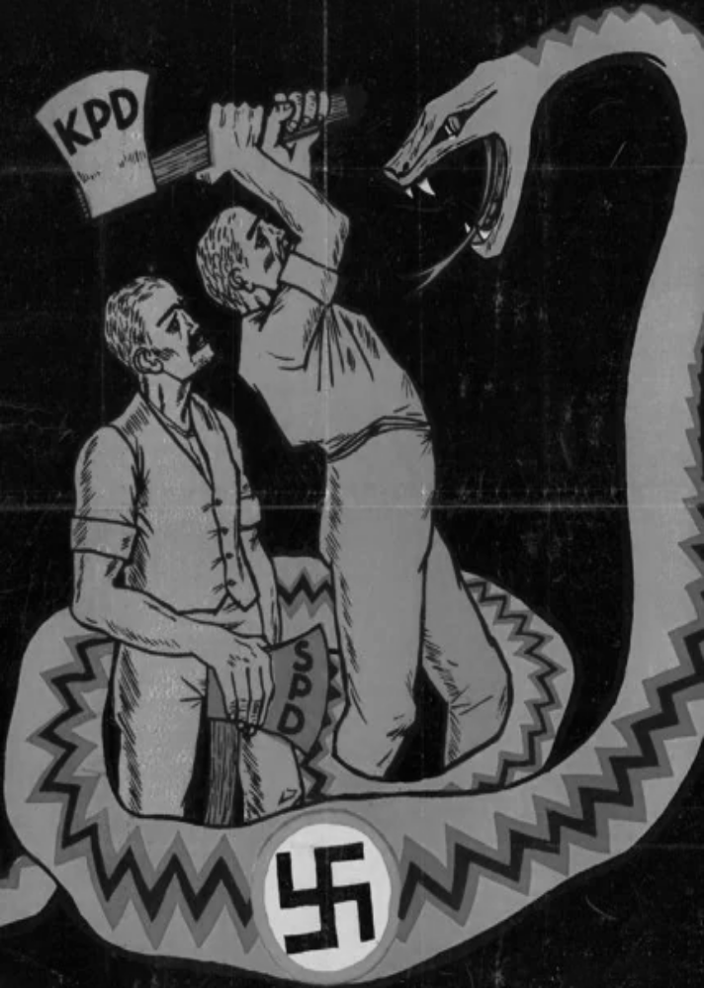
By
Cecelia Bobrovskaya
1938

The sharper the struggle between the two worlds, the wider the scale on which the viper of provocation sets its nests, and the more refined are the methods with which the hell’s kitchens of the fascist secret services concoct their poisonous fare. The secret police employ the services of traitors, degenerate Trotskyite elements, and systematically attempt to disrupt the struggle of the Communists and anti-fascists. A tense daily struggle is necessary against this cankerous evil.
A careful study must be made of every link in the foul chain of provocations whereby the fascist secret services endeavor to enmesh entire organizations of Communists and anti-fascists, as well as individual active members of these organizations. We must learn to uncover the cunning methods of work of the enemy, using concrete examples to expose every attempt at provocation.

THE GESTAPO

This “firm,” which has its branches all over, carries on its work on an extensive scale. Here they “work” without regard to means, expenditure, time or distance and, as is clear from the facts quoted below, pay great attention to enabling Gestapo agents to penetrate among German political émigrés in different countries. Use is made for provocative ends of the desire of all antifascists for the united fighting front against fascism.
First example. The Gestapo makes an agreement with its kindred fascist organization, the Henlein Party in Czechoslovakia. A member of this organization, T., is given the task of “moving to the “Left,” organizing an opposition, and refusing to obey discipline so as to get expelled from the Henlein Party.
After the “expulsion” the “victim,” in fulfilment of the task set by the Gestapo, links up with Czech Social-Democrats. He convinces them that he has completely broken with Henlein, that he completely accepts the program and tactics of the Social-Democratic Party, with which henceforth he has everything in common, and that therefore he would like formally to enter its ranks.
Shortly afterwards he is accepted into the Socialist Party. This new-fangled “Social-Democrat” displays great interest in questions of the united front, and seems to be particularly active in this regard. After a time, he insists on the need for establishing contacts primarily with German Communists, who are “more decent than the Czechs” and secures that the united front negotiations with the German Communists are entrusted to him.

During the negotiations with the Communists, this “representative” of the Social-Democratic Party informs them that he is in addition in contact with certain Catholics living in Germany, who are also interested in united front questions, and that this work could be developed, etc.
The “representative” of the Social-Democratic Party displays an absolutely extraordinary anxiety to secure the joint organization of the transport of literature of the border. It turns out “quite accidentally” that he has a woman friend who lives in an isolated cottage right close to the border, that it ought to be possible for messengers engaged in the transport of literature to stop at this secluded spot, that in case of need the messengers could wait there, stop the night, etc. In a word, everything seems to fit in automatically.
This inordinate readiness, excessive haste could not fail to arouse a certain suspicion among the comrades, who began to make an attentive examination of this individual. They asked him searching questions and when he lost his patience, this luckless agent of the Gestapo in reply to a blunt question put to him as to whether he was still a supporter of Henlein, suddenly burst out: “Go to the devil, I don’t want to be anything at all.”
It goes without saying that the cottage on the border so kindly offered by the provocateur was supplied with both radio and telephone, had long been a favored haunt of the Gestapo, that the owner of this house was a Gestapo agent, and that altogether the Gestapo ruled the roost there.
A second example shows another type of the Gestapo’s work, calculated for a longer period of time.
The Gestapo sends a certain G., expelled from the Communist Party of Germany in 1933, abroad. It sets him the task of linking up with German Communist émigrés, leading officials living abroad. By reason of his past, G. finds it difficult to establish immediate contact with the Communists, and so he is instructed to go a round-about way, to take time about it.
On his arrival abroad, he passes himself off as an anti-fascist who has been through the mill in Germany and has been compelled to emigrate because of Gestapo persecution. He appeals to the Matteotti Fund for help. He receives this aid and as a fully-fledged political émigré begins to interest himself in the trade union movement of the country in question, makes fiery revolutionary speeches at general trade union meetings, makes personal contacts with leading trade union officials, and gradually worms his way into the trade union leadership.
Thus, step by step, over a period of eighteen months, this Gestapo agent makes his way into the leadership.

Having become an important figure, the provocateur is already approaching the fulfilment of the mission allotted to him by the Gestapo. The trade unions empower him to undertake united front negotiations with leading officials of the German Communist Party. Unexpectedly for himself, however, the provocateur was recognized and the “whole affair” fell through not only as far as he himself was concerned, but also as far as concerned two other provocateurs connected with him, of whom one was operating in the Ruhr basin, and the other in another big industrial center.
Third example. The Gestapo dispatches three of its young hirelings abroad, and instructs one of them to worm his way into the confidence of Catholic émigrés, the second to win the confidence of the Social-Democrats, and the third, of the Communists. Each of them is to make use for espionage and provocative purposes of the strivings of the anti-fascists for the united front.
The provocateur sent to the Catholics succeeds without any particular difficulty in getting himself established among them. The second Gestapo agent meets with some difficulties, but still is not without success in penetrating among the Social-Democrats. He mentions the names of several people with whom he was supposed to be connected in Germany, and is believed.
The third provocateur meets with defeat. As soon as he comes to the Communists, he immediately demands that he be given Party materials allegedly for dispatch to Germany. In reply to a question as to the name of the person whom he wants to supply with these materials, he gives a fictitious address. After a careful check is made, it becomes possible to expose the provocative role of the united front “enthusiast” in question, and through him the two provocateurs who have crept into the ranks of the Catholics and Social-Democrats.
The following fact is also not without interest as an illustration of how carefully the Gestapo guards its agents against discovery.
On one occasion the Gestapo succeeded, after beating up an arrested Communist in jail for five months, in forcing him to agree to become a Gestapo agent. During the whole of this time, he was kept in the strictest isolation. The Party organization knew nothing of his arrest and only presumed that he had been arrested.
The Gestapo on enrolling an agent is interested in his appearing to be “pure” to those who know him, for if he emerges from prison, his friends will be afraid to make immediate use of him. And so, in this case the Gestapo resorted to the following trickery. Before releasing him, they dispatched the prisoner for several days to a tuberculosis sanitorium, and introduced him to the head doctor, a fascist. This individual acquainted him with the routine and the locality of the sanatorium, after which he was released with a document stating that “Mr. N. (name, etc., according to his passport) received treatment in the above sanatorium between May and September for two broken ribs and injured lungs following on an automobile accident. The expenses for treatment have been covered by the head doctor, the one to blame for the motor accident.” The signature of the head doctor, and the seal of the sanatorium follow.
However fine, at first glance, the trickery of the Gestapo, the Party soon exposed this agent as well, because from the very first steps of his provocative activity, he began to display great nervousness, get mixed up in his stories about his stay in the sanatorium, so that in the long run the only thing that could be believed about him was that he had a broken rib, But neither the automobile nor Hitler’s jail thugs had broken the ribs of their future colleague.
In all the examples above quoted the provocateurs were in the last analysis exposed, thanks to the vigilance displayed by the Communists. Nor were these provocateurs helped by the Gestapo instructions for agents sent abroad. Among other things these instructions contain the following: “On your arrival abroad you must count on not being immediately accepted by your people, and on having to hang around for weeks and perhaps months.
“You must pay careful attention to ensure that there are no contradictions in the statements you make; you must not display any signs of being upset, even when you see that things are not going well. You must not pester people, must not hurry to be given work to do, etc.
The Gestapo has need of many ‘‘cadres” as the following little table shows.
In a period of three months, Gestapo agents were exposed as follows: Prague, 17; Zurich, 5; Belgium, 10; Amsterdam, 6; Copenhagen, 3. In all a total of 41.
They were all sent by the Gestapo to establish contacts with leading officials of the Communist Party of Germany; they all of them made efforts to be sent back to Germany as Party instructors.
Not only does the. Gestapo supply its “cadres” with instructions, not only are the most qualified of them given a theoretical examination in schools specially designed for provocateurs, but they also undergo “practical training.” Thus, for instance, an individual makes his appearance abroad from Germany, having crossed the border illegally; he comes to the house of some comrades living in emigration and informs them that he has made a successful escape from Gestapo persecution, gives some general information about himself, and makes an arrangement to meet the comrades the next day so as to have a more detailed conversation with them. When the “next day” comes, there is no trace left of this “emigre.” He was simply a Gestapo agent on trial, undergoing a practical examination, and had returned to the lap of the Gestapo.

Of the foul methods employed by the Gestapo to force arrested people to make treacherous admissions, we will draw attention here to a case, exceptional for its effrontery, that took place recently.
After several months of severe prison treatment, beatings up and savage ribaldry over the enfeebled body and spirit of a prisoner, they resorted to the following experiment. They called in his fiancée and told her that the prisoner would be released if he gave a certain address, that there was no “compromise” in this, that in any case the Gestapo knew it but that all that was important for the Gestapo was to establish “how far this person is capable of speaking the truth,” etc.
Having thus entangled the girl and received her agreement to persuade her fiancé to make this “compromise,” they arranged a meeting between thein. But this was no ordinary prison visit with witnesses present. She was admitted to the prison cell. The meeting lasted two hours.
The aim of the Gestapo was achieved; the required address was secured; the treachery was accomplished.
Vigilance on the part of Communists is necessary in any sphere of activity, and in every situation.
The methods of provocation employed by the doomed enemy are very dangerous weapons drawn from the arsenal of extreme measures. It must be borne in mind that the more hopeless the position of the enemy, the more eagerly “will they seize hold of the most desperate methods of struggle, as the last resort of people doomed to destruction.”
Unflagging attention, a sharp eye, complete calm without excessive nervousness and suspicion, ever on guard—such are the qualities which will enable the Communist and anti-fascist to recognize end expose provocation in good time, however cunningly it is concocted.

Prepared by Maoism Library from “The Communist International 1938-03: Vol 15 Iss 3”

