INCREASE STUDENT ORGANIZATION AND STUDENT STRUGGLE

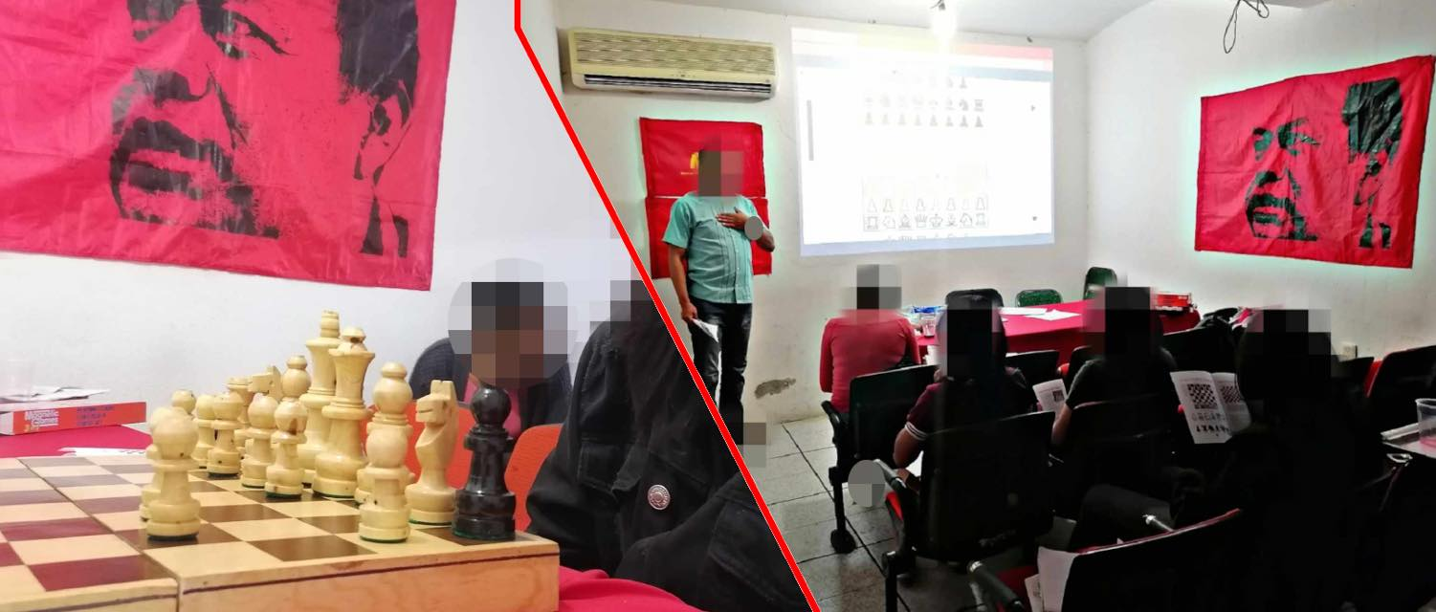

By
People’s Student Movement Mexico (MEP)
2021

In the midst of a complex situation for the youth, marked by the pandemic and the visibility of the inequalities suffered by the popular sectors, the voices of the national teacher training movement, specifically the rural teacher training movement, have resounded strongly, demanding the application of classroom exams, supported by booklets, for the daughters and sons of the working class and the poor peasantry who wish to train as teachers of the people.
As we were able to document in our last issue of Periódico Mural, the state's response has been open, systematic and brutal repression against this youth eager for scientific knowledge.
It is worth noting that the profound inequalities experienced in Mexico from below are not only suffered by those who aspire to enter normal education, but also by all the children of the common people who wish to continue their studies.
Indeed, the lack of access to smart devices such as cell phones, tablets, laptops, desktop computers, etc. as well as the lack of economic resources to access internet services or prepaid tokens have excluded millions of children and young people from the constitutional right to public, free and scientific education, marking a group of people to whom the pandemic and misery denied the possibility of academic training.
In this context, a group of young people from various schools in the state of Oaxaca have also formed a platform of organization and struggle that already has supporters in other schools and entities of the country, shaping up towards a national project.
The People’s Student Movement was born precisely with very clear objectives. precisely by setting very clear objectives, that show us the degree of awareness and historical commitment of the youth to the processes of processes of social change.
In a brief communiqué addressed to applicants who wish to enter the Benito Juárez Autonomous University of Oaxaca (UBAJO), the MEP has pointed out that its work and program of struggle is based on four points:
- In defense of free public education at all levels. at all levels. For universal access to education and lower tuition fees in public institutions. Institutions.
- In defense of the academy and against the bureaucratization-right-wingization of public education. Education.
- In defense of university autonomy and democracy, against the interference of the old state, its governments and its electoral parties; for the eradication of criminal cheerleading.
- In support of the just struggles of the people, for the New Democratic Revolution and Socialism in Mexico. in Mexico. In defense of proletarian internationalism, the struggles for national liberation, the people's wars in the world and the World Proletarian World Proletarian Revolution.
From Periódico Mural we recognize the efforts of these young people who identify the path of democratic and revolutionary struggle as the north to follow, both for the defense of their rights and for the emancipation of their people.

Translated by a supporter of Maoism Library from https://muralperiodico.wordpress.com/2021/07/06/no-es-tiempo-de-vals-sino-de-rebelion/ . Prepared by Maoism Library
A democratic and people’s press based in Mexico

