On the Tasks of the Partisan Movement

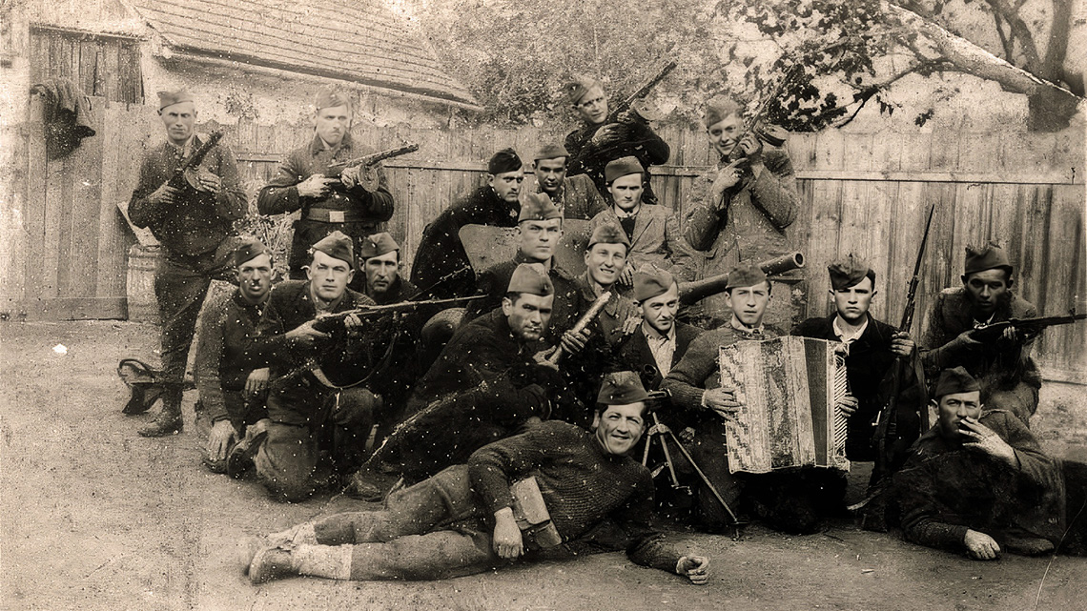

by
People's Commissariat of Defense of the Soviet Union,
1942

For the second year, the peoples of the Soviet Union have waged the Great Patriotic War against the German fascist hordes treacherously invading the territory of our country.
The German imperialists, having captured and robbed the whole of Europe, set as their goal to ruin our country and plunge the peoples of the Soviet Union into German slavery. The enemy managed to capture Ukraine, Belarus, Lithuania, Latvia, Estonia, Moldova and part of the North Caucasus, and continues to siege Leningrad. Regardless of his enormous losses, the enemy throws all of his forces to the front and continues to break into the depths of our country.
At this moment of greatest danger to all the peoples of the Soviet Union: to every citizen at the front and rear, in the occupied territory, and in the partisan detachment, there is only one task - to defend their homeland, protect freedom, independence, and honor, and to defeat the hated German invaders.
The Red Army heroically reflects the onslaught of the enemy and inflicts crushing blows on it. She exhausts his strength, inflicting huge damage on him.
The working people of the Soviet Union, at factories, on collective farms, and on state farms, work hard and selflessly day and night in the production of weapons, ammunition, equipment and food for the Red Army. Our industry now provides for the needs of the front. The army receives more and more tanks, planes, artillery, mortars and ammunition. The combat power of the Red Army has grown significantly and continues to grow.
However, the defeat of the German armies can only be carried out by simultaneous combat operations of the Red Army at the front and powerful, continuous strikes by partisan detachments on the enemy from the rear.
The history of wars teaches that victory over invaders was often achieved not only by the struggle of one regular army, but also by a popular guerrilla movement, which contributed to the final defeat of the invaders.
So, it was in the Patriotic War of 1812. Napoleon, trying to conquer our country, was finally defeated by the Russian army, supported by the armed people, who launched a merciless partisan struggle in the rear of the enemy. The Napoleonic army, at that time the strongest in the world, laid bones in Russia, because along with the regular Russian army, a powerful popular partisan movement rose to defend the fatherland.
So, it was during the years of the civil war. The Red Army defeated the interventionist armies on all fronts and defended the young, in mortal danger, Soviet Republic, thanks to the armed struggle of the whole people who organized the partisan movement in the rear of the enemy armies.
Now that the Red Army at the fronts, straining all its forces, defends the freedom and independence of its state, the popular guerrilla movement in our territory, temporarily captured by the German invaders, is becoming one of the decisive conditions for victory over the enemy.
Having captured the territory, the Germans could not conquer the Soviet people. Our people hate the invaders; they take up arms and organize a guerrilla war in the rear of the German army. Partisans cause serious damage to manpower, equipment and disorganize the rear of the enemy. However, the partisan movement has not yet fully unfolded, it has not yet become the business of everyone who has found themselves in the clutches of the German predators, even while there are all the conditions for the widespread rapid development of a popular partisan struggle against the German invaders.
First of all, it is necessary to ensure that the partisan movement develops even wider and deeper; it is necessary that the partisan struggle embraces the broadest masses of the Soviet people in the occupied territory. The partisan movement must become popular.
This means that the partisan detachments existing now should not become isolated, but involve more and more broad sections of the population in the partisan struggle. Along with the organization of new partisan detachments, it is necessary to create partisan reserves among the population, from which to replenish or form additional new units. It is necessary to conduct the matter in such a way that there is not a single city, village or settlement in the temporarily occupied territory, where there would not be a hidden reserve of the partisan movement. These hidden guerrilla warfare reserves should not be numerically limited and include all honest men and women wishing to free themselves from German oppression.
The main tasks of the guerrilla war: the destruction of the enemy rear, the destruction of its headquarters and other military institutions, the destruction of railways and bridges, the arson and explosion of warehouses and barracks, the destruction of enemy forces, and the capture or destruction of representatives of German authorities.
At the moment, the destruction of the enemy’s transport routes is of utmost importance. The enemy is now forced to transfer reserves, military equipment, fuel and ammunition to the front from the far rear, as well as transfer looted bread, meat and all other property from our country to Germany. The railroads, highways along which the enemy feeds its troops, stretched for thousands of kilometers. In many places they intersect with forests. This creates favorable conditions for the action of partisan detachments to destroy supply routes. To close the supply routes means to deprive the enemy of the opportunity to replenish the front with manpower, equipment, fuel, ammunition, and also to export to Germany looted in our country popular property and thereby facilitate the destruction of the enemy of the Soviet Union.
The execution of these basic tasks requires all partisan detachments to widely deploy combat partisan operations, as well as sabotage, terrorist, and reconnaissance work behind enemy lines.
I order:
- In order to disrupt the movement on railways and disrupt regular traffic behind enemy lines, arrange railway accidents by all means: undermine railway bridges, blow up or burn station facilities, and blow up, burn and shoot locomotives, wagons, and tanks at stations and siding. In case of railroad wreck, destroy manpower, equipment, fuel, ammunition and other cargo, as well as surviving steam locomotives and wagons. On highways and dirt roads, undermine and burn bridges and viaducts; destroy ghats and other man-made structures. Destroy transports delivering ammunition and fuel. Steal any horses. If it is impossible to use weapons, transports or cargoes, render them unusable by all possible means.
- Whenever possible, destroy military garrisons, headquarters and institutions, troops, and separately follow officers and soldiers guarding transports and warehouses.
- Destroy warehouses and bases of weapons, ammunition, fuel, food and other property, garages and repair shops.
- Destroy communication lines on railways, highways and dirt roads, destroy communication equipment, cut and take away wires, cut and burn telegraph poles, and kill radio stations and their staff.
- Attack airfields and destroy aircraft, hangars, bombs and fuel depots, as well as the flight personnel and guard airfields.
- Destroy every kind of economic commands, enemy foragers, and commands and agents for the seizure of grain. attack the wagons and warehouses containing bread; if possible, distribute bread to the population, and if this cannot be done, completely destroy it.
- Partisans have not yet reached the cities. Partisan detachments, individual organizations, and saboteurs must penetrate into all cities, large and small, and widely deploy intelligence and sabotage work there. Destroy and burn communication centers, power plants, boiler plants, water supply, warehouses, fuel tanks and other objects of military or economic importance.
- Ruthlessly kill or capture fascist political figures, generals, significant bureaucrats, and other traitors to the Motherland who are in the service of the enemy. Constantly monitor the generals and major officials. Find out where and on what path they go, with whom they spend time with, their behavior, and who protects them and how.
- Conduct reconnaissance and intelligence work for the Red Army:
  - Carefully select people capable of conducting covert reconnaissance work and put them into service in local administrations and institutions created by the Germans, in factories, depots, stations, marinas, telegraphs, airfields, bases and warehouses, in the protection of German officials, in the Gestapo and its schools, as well as all other institutions and bodies serving the army or local administration of the German authorities;
  - Constantly keep track of the location and movement of enemy forces and supplies by rail and road; find out the number, type of troops and numbering of units, the number and type of military equipment, direction of movement and time of movement; establish the order and strength of protection of military echelons and transports;
  - Establish the precise locations of enemy troops and headquarters, their name and numbering, and institutions and bodies of the occupying authorities;
  - Make observations of enemy airfields: establish their location, number and types of aircraft permanently or temporarily based on a given airfield, airfield equipment, auxiliary and special vehicles, fuel and oil reserves, as well as the protection of airfields on the ground and from the air;
  - Perform reconnaissance work on towns and major population centers with the aim of finding the number, name, type, and commander of troops in their garrisons and anti-aircraft defenses, as well as gathering intelligence on any military factories or workshops;
  - Find where and what sort of defensive lines have already been constructed, their composition in an engineering sense, weapons, communications, and whether they are garrisoned or not;
  - Monitor and accurately record the results of bombing by our air forces;
  - Take all opportunities to steal orders, reports, operational maps, and other enemy documents.
- Along with work in warfare, conduct political work amongst the population: clarify the truth about the Soviet Union, the merciless struggle of the Red Army and the entire Soviet people against the fascist invaders, and about the inevitable death of bloodthirsty invaders. Expose the false German propaganda and describe the facts, instilling hatred and bitterness towards the German invaders. Organize the publication of newspapers, leaflets and other printed materials in the occupied territory.
The Supreme High Command of the Red Army requires all leading bodies, commanders, political workers and fighters of the partisan movement to expand the fight against the enemy in its rear even wider and deeper, to beat the fascist invaders continuously and mercilessly, without giving them a break. This is the best and most valuable thing that will help the Red Army.
By the joint effort of the Red Army and the partisan movement, the enemy will be destroyed.
People's Commissariat of Defense of the Soviet Union
I. STALIN

№ 00189 | 5 September 1942

Prepared by Maoism Library from https://en.wikisource.org/wiki/Translation:On_the_tasks_of_the_partisan_movement

