Antifascism and revolutionary violence – what can we learn from history?
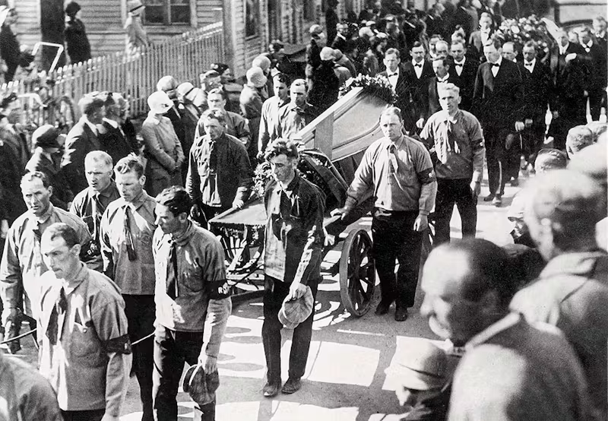

By
The Communist Association (Sweden)

In light of a general increase in reactionary sentiment in Swedish society, driven by the decay of the imperialist world system, which is reflected in Sweden by the intensification of the conflict between labor and capital, we understand that the issue of fascism and anti-fascism is on many people’s minds. We understand that the old “violent right” is on the rise again. In recent years, we have had a taste of this with the attack in Gubbängen in 2024 and the assaults in central Stockholm in early September last year. This is not surprising. We understand that movements come and go. The same applies to the so-called “anti-fascist left.” This movement, which barely exists today, will experience an upswing along with the former. They exist in dependence on each other.
In light of this, Kommunisten wishes to contribute to the discussion on what anti-fascism means, and to do so, let us first clarify what fascism is. Furthermore, we believe it is important to clarify what revolutionary violence is and is not.

What is fascism?
During the Comintern era, fascism was defined as the most reactionary, openly terrorist form of the dictatorship of finance capital that the bourgeoisie establishes to suppress the working class and all progressive forces in society. This definition has since been developed after the Comintern era by Chairman Mao and Chairman Gonzalo, where fascism is defined as a form of government – not a set of laws or opinions of a few rulers. Something can be reactionary without being fascist. Confusing the two means that “all reactionaries become fascists” and thus the understanding of fascism loses its relevance.
As Chairman Mao taught us, we distinguish between state system and form of government as two parts of a whole, where the question of state system is the place that classes have in the state (which class dictatorship prevails) and the form of government is the way in which these ruling classes organize their power. The form of government in a given country, under a bourgeois state system, can be either bourgeois democratic or fascist. But in both cases, it always represents the dictatorship of the reactionary classes. If one does not understand fascism in this way, one makes the mistake of equating fascism with dictatorship, and thus a bourgeois democratic government is not a dictatorship. Then one follows like a tail one of the factions of the monopoly bourgeoisie based on the farce of “defending democracy” or “voting for the least bad.”
It is also important to clarify that fascism is not merely a lack of “democratic rights,” as many people believe. There is no state in the world (apart from the new powers in the people’s wars, where a new state is being built) where developments are moving toward giving the people more democratic rights.
Fascism emerged during the crisis of democracy. One of the first Marxist-Leninists to study fascism during its emergence was José Carlos Maríategui, founder of the Communist Party of Peru, who lived in Italy under Mussolini. In his book The Crisis of Democracy (1923), he pointed out how capitalism’s fundamental contradiction, between the increasingly socialized nature of production and its private appropriation, expressed in the contradiction between the bourgeoisie and the proletariat, has undermined democracy, so that parliament becomes merely the parliament of the ruling classes. From the birth of the bourgeois state, when the bourgeoisie was the vanguard of the people and led the bourgeois-democratic revolution to victory, a process of decay began. The core of bourgeois democracy was that parliament was the legislative branch of the state. In the beginning, parliament was divided between two factions of the bourgeoisie, the conservatives and liberals, and class parties, such as workers’ parties. But when free competition turned into its opposite—monopoly—democracy went into crisis. The dividing line between the conservative and liberal sections of the bourgeoisie was blurred. Legislation began to be increasingly transferred from parliament to technical committees, advisors, lobbyist groups, etc. All these gigantic entities of unelected bureaucrats surrounding parliament write the bills. And elections to parliament now serve almost exclusively to legitimize the bourgeois dictatorship. This created the conditions for fascism – a crisis in parliament, which meant that parliament was increasingly subjugated to the executive branches of the state.
In the age of imperialism, there is no faction within the bourgeoisie in the imperialist countries that constitutes a progressive element. They apply reaction across the board. This means that the tendency is for bourgeois democratic rights to be reduced.
We would also like to clarify that fascism cannot be reduced to the use of violence and terror. Chairman Gonzalo explains in an interview with the newspaper El Diario in 1988 how:
” With regard to identifying fascism with terror, with repression, we think that this is a mistake. What’s involved is the following: if one remembers Marxism, the State is organized violence, that is the classic definition. All states use violence because they are dictatorships How else would they assert themselves to oppress and exploit? They couldn’t do it. Consequently, what happens is that fascism develops a broader, more refined, more sinister violence. But to identify fascism as being the same as violence is a crass error.”
So, what constitutes fascism and what is its core? Fascism has three central components:
- Negation of civil democratic rights
- Corporatism
- Philosophical eclecticism
The negation of civil democratic rights must be understood as the negation of parliament. Parliament loses its function when decisions on which laws to enact are made in other chambers. This does not mean that parliament needs to be closed, but that legislation does not come from parliament but from the executive branches of the state. In Sweden today, we are seeing the restriction of most bourgeois democratic rights. There is no true freedom of assembly, as you must obtain permission from the police for public gatherings, and there is no freedom of expression, as we have laws against hate crimes, etc. But again, the denial of civil democratic rights is not enough for a state to be fascist, because then all the countries in the world would be fascist and the word would lose its meaning. The core of fascism is corporatism.
Corporatism means that the state is built on corporations. The word corporatism comes from the Latin “corporo,” which means to make into a body—the state should be made into a body. Corporatism means that society is built on Mussolini’s thesis “everything within the state, nothing against the state, nothing outside the state.” Corporatism attempts to organize the state on the pretext of class cooperation, which is false since class antagonisms remain and are intensifying. Corporations give the state-monopolistic faction of the upper bourgeoisie an advantage over the private faction of monopoly capital. The state-monopolistic faction within the bourgeoisie is based on a high concentration and centralization of capital, the omnipotence of monopolies in the economy and politics of capitalist countries, which leads to a fusion of the monopoly apparatus and the state apparatus. The financial oligarchy subjugates the bourgeois state. This faction uses state intervention and state-owned companies to strengthen its own position and increase its own share of capital domination. For example, LKAB, a state-owned mining company where both Marcus Wallenberg and Göran Persson have served as chairmen of the board, generates large profits for the Wallenbergs by purchasing products from, for example, Atlas Copco (also owned by the Wallenberg sphere). Various groups of monopoly capitalists are drawn into the struggle for control of the state apparatus, for positions in state bodies (directly or through proxies) and to seize as much as possible of the state pie. The conflict between the private and state factions within the upper bourgeoisie is real and fierce, which is why the introduction of fascism is not a simple but a difficult process, not only because of the masses’ contempt for fascism but also because parts of the bourgeoisie despise it. For private monopoly capital, corporatism can be seen as expensive and full of concessions to both government spending and the other faction within the upper middle class, which is its competitors. Here we want to reaffirm that the bourgeoisie is fundamentally an individualistic class that cannot serve any real class solidarity but only conspires when it benefits them, but basically sees each other as competitors and not as teammates.
The building blocks of corporatism are constructed by incorporating a mass movement under state control. To do this, fascism must be able to mobilize discontent among the people. The crisis in society is reflected in the consciousness of the masses. The masses listen to the voices of those who are confident. If the communists do not offer answers, they turn to those who do. Chairman Gonzalo teaches us that the masses are a battlefield and can thus be driven in the direction of both the communists and the fascists. To tie back to Mariátegui, all discontent in society can either serve the bourgeoisie or the proletariat, due to the fundamental contradiction of capitalism. In order to attract the discontent of the masses into the embrace of the big bourgeoisie, the fascists need to use rhetoric that appeals to the masses and that can partially reflect their worldview. But at the same time, the fascists must use lies to hide the fact that class society and the exploitation of one class by another are the cause of their problems. Hence, fascism is philosophically eclectic. It has no principles, but its core is populist and adaptable to the discontent of the masses.

The European roots of fascism
“Fascism is not a party; it is an army… a counterrevolutionary army, mobilized against the proletarian revolution… Their only recourse is violence. Peace for them means inaction, unemployment.”
– Mariátegui 1924 (History of the World Crisis)
When the crisis of democracy broke out during capitalism’s transition to its highest stage—imperialism—a process of reactionary transformation of the whole of society began. This happened at the same time as the First World War broke out as a war of redistribution between the imperialists over spheres of interest, colonies, and semi-colonies. The First World War left large parts of Europe in ruins, which also gave rise to a wave of proletarian revolutions that rose from the ashes of inter-imperialist destruction and, for the working class, a betrayal by revisionists, reformists, and parliamentarians who happily beat the drums of war on behalf of the bourgeoisie.
These revolutions became the basis for the formation of the Comintern and a break with social democracy, but despite this, the revolutions were a loss in some cases, including in Germany and Hungary. However, these uprisings had now revealed a frightening reality for the bourgeoisie. The proletarian revolution was now a fact, threatening the survival of capitalism.
In Italy, no uprising had begun, but the class struggle had developed to higher stages year after year, and during the 1920s this was mainly expressed in strikes among the working class, especially in northern Italy. For workers in the country, the war had brought about a reality of increased poverty; among other things, the cost of living for a working-class family had risen by 560% since 1914, despite Italy emerging as a “victor” with new territories and a larger population.
The state had difficulty dealing with the increased tensions, and in many cases neither the police nor the army could prevent the people from attacking landowners and factory owners. In many cases, workers established their own councils, similar to previous socialist revolutions, and occupied land belonging to landowners in rural areas. This was a direct threat to the power held by the ruling classes in Italian society, and it was now important for the bourgeoisie to find a new solution to overthrow the resistance, as the bourgeois state was no longer sufficient.
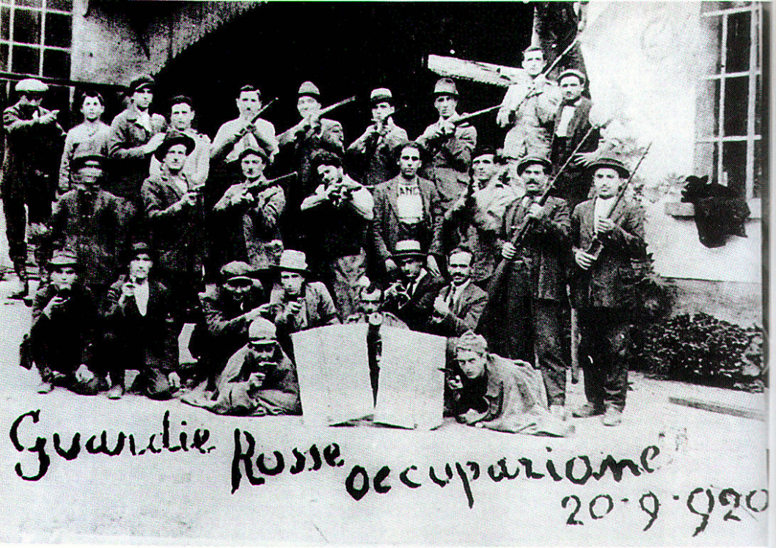
The Red Guards occupy a factory, 1920.
The fascists used revolutionary rhetoric to capture the discontent among the masses. The National Fascist Party, founded in 1921, declared that the party would function as “a revolutionary militia at the service of the nation. It follows a policy based on three principles: order, discipline, hierarchy.” They tried to blur class antagonism by promoting the message of class collaboration in the service of the nation. This was despite the fact that it had its roots in the syndicalist movement.
The Blackshirts, officially called the “Voluntary Militia for National Security,” were formed as the paramilitary wing of the Fascist Party under the leadership of former syndicalist Benito Mussolini. In its early days, it was mainly composed of nationalist intellectuals, army officers, and landowners, who saw the “radical labor movement” as their greatest enemy. The main funding for their movement came from capitalists in Italian heavy industry, including Fiat, which later developed vehicles for the Italian army during World War II. It is clear that Mussolini succeeded in obtaining this funding precisely because he promised better conditions for capital owners in Italian industry. However, the capital linked to industry was the same capital that was linked to the state-monopolistic faction within the big bourgeoisie.
Initially, Italian fascism’s economy was a compromise with the liberals, with Mussolini readily changing his tune to gain popularity and consolidate his power. In several speeches, he stated, among other things, that “the state must remove its sticky fingers from industry.” In typical eclectic fashion, Mussolini, in the service of the upper classes, was able to use the state apparatus to advance industry, despite his earlier words. As the power of fascism became increasingly consolidated, state-monopolistic capitalism developed. During the Great Depression, several private companies were taken over by the state, which was not always welcomed by the private monopoly capitalist faction within the upper classes. In 1939, fascist Italy achieved the highest degree of state ownership of the national economy in the world outside the Soviet Union. The Italian state “controlled over four-fifths of Italy’s shipping and shipbuilding industry, three-quarters of its pig iron production, and almost half of its steel production.”
A major misconception that is rarely discussed in the mainstream media is how the fascists got their hold on power. The “March on Rome” is often cited as some kind of revolution, but in fact this event was more symbolic in nature. In reality, Mussolini formed a coalition government together with the liberals, Christian Democrats, and Social Democrats from Democrazia Sociale. It was this coalition, created in 1922, that lasted until 1924, when Mussolini finally had his own majority, which enabled him to abolish bourgeois democracy, entirely within the law and with the support of the Italian king.
In addition to attacking the communist movement, they also took on the role of strike breakers and carried out work while the proletarians were on strike. However, it was not the fascists who forced the occupations and strikes to end, but rather this directive came from the reformist leadership of the Social Democratic Party. Nevertheless, this demonstrates the recurring elements that give rise to fascism. A bourgeois state in crisis, threatened by the proletarian revolution. A retreat by the domestic ruling classes. And, of course, a wavering of the bourgeois-democratic parties, which often form alliances with the fascists.
What we must also understand in our analysis of fascism is that it does not always take the form of an explicitly fascist party or always take a stand for racist or other chauvinistic positions. If we look at the Swedish context, it was rather social democracy that became the leading force capable of introducing fascism into our country, where it was precisely the social democrats who led the struggle that resulted in communists being imprisoned in labor camps.
” Firstly, it is not true that fascism is only the fighting organization of the bourgeoisie. Fascism is not only a military-technical category. Fascism is the bourgeoisie’s fighting organization that relies on the active support of Social-Democracy. Social-Democracy is objectively the moderate wing of fascism. There is no ground for assuming that the fighting organization of the bourgeoisie can achieve decisive successes in battles, or in governing the country, without the active support of Social-Democracy. There is just as little ground for thinking that Social-Democracy can achieve decisive successes in battles, or in governing the country, without the active support of the fighting organization of the bourgeoisie. These organizations do not negate, but supplement each other. They are not antipodes, they are twins. Fascism is an informal political bloc of these two chief organizations; a bloc, which arose in the circumstances of the post-war crisis of imperialism, and which is intended for combating the proletarian revolution. The bourgeoisie cannot retain power without such a bloc. It would therefore be a mistake to think that “pacifism” signifies the liquidation of fascism. In the present situation, “pacifism” is the strengthening of fascism with its moderate, Social-Democratic wing pushed into the forefront.”
– (Stalin, Concerning the International Situation, 1924)
Otherwise, fascism has taken many different forms. One of the cornerstones of fascism is its philosophical eclecticism, which never has any concrete fixed principles, but can also take shape in the monarchy, as it did to some extent in Italy, Spain, and Portugal, which also used the church as a tool for the fascist state. This differed from Germany, which never showed any interest in reinstating the German monarchy. Racial biology issues were raised far more by the German fascists than by the Italian and Spanish fascists, for example. In countries ruled by modern revisionists, the fascists relied on former workers’ organizations (communist parties, trade unions, mass organizations, etc.) as organs of power. In Sweden during the period around World War II, the social democratic trade unions were used to turn workers into strike breakers.

The roots of the antifascist movement
The fight against fascism is a long and hard history, which originated mainly in Italy and Germany in the 1920s. The first explicit anti-fascist movements emerged in the struggle against Mussolini, including Arditi Del Popolo, which was founded by socialists and communists in 1921 and mainly resorted to violent street fighting and barricades against the fascist black shirts. The fascist state responded with unprecedented violence, imprisoning and murdering all the leaders of the group, which led to its demise.
The struggle in Germany was subsequently developed by the KPD (Communist Party of Germany), which founded the Roter Frontkämpferbund (RFB) in 1924 as a paramilitary organization focused on recruiting the foremost class warriors and developing a military structure capable of using revolutionary violence against its enemies, including the Sturmabteilung (SA), which was the Nazis’ equivalent of a paramilitary organization.
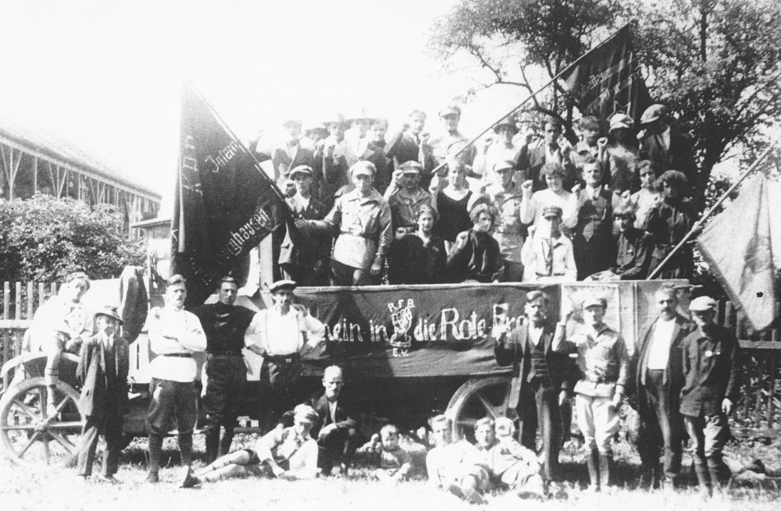
Members from RFB.
The KPD claimed to be the only consistently anti-fascist force in Germany, which was further proven when the SPD (Social Democrats) banned the RFB in 1929 on the grounds that they were a security threat, after they demonstrated on May 1, 1929, in Berlin, something that was prohibited by the city’s social democratic police force. This led to several deaths among the demonstrators.
At its peak, the RFB had close to 130,000 members, with a composition of 98% working class and only 1-2% highly educated. 53% were party members of the KPD. In addition to this, youth groups and women’s groups were also formed within the union to reach out to more sections of the population.
The union’s work mainly consisted of providing security and support during demonstrations, where they collaborated with trade unions to defend actions from possible fascist attacks. On other occasions, they acted in defense of workers who were evicted by landlords. Overall, the RFB became a proletarian organization that was able to “go further” in its actions, and when revolutionary violence proved successful, the state did not hesitate to ban the organization.
As a result of the ban, the KPD also formed the Antifascist Action (AFA) union, whose memory is still evident today in the continued use of the organization’s name and symbol in hundreds of modern groups.
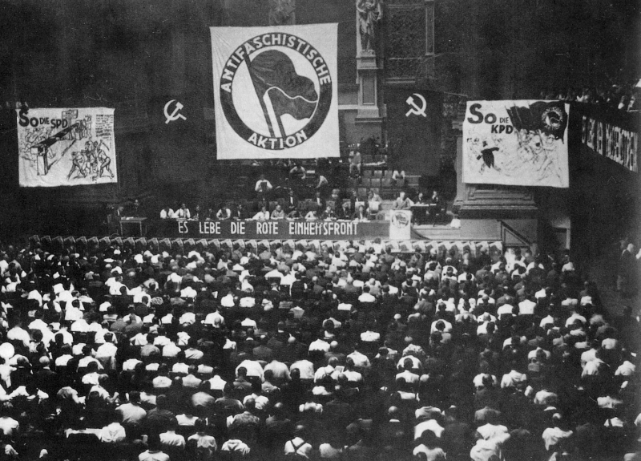
The founding of AFA, 1932.

The Swedish communists and the antifascist work
A similar organization was also founded in Sweden in 1930, under the name Röda Frontförbundet (Red Front Association), also led by the SKP. Like its German counterpart, the Red Front Federation was intended to act as a defense organization and as an embryo for the Red Army. In 1931, there were 15 local groups with up to 1,500 members, and a youth organization was also formed under the name Antifascist Youth Guard or Antifa. Those who became members of the organization also had to swear an oath of loyalty to the class struggle, which read:
“We, the class-conscious proletarians, swear: to devote all our energies to the struggle for the liberation of all workers from capitalist exploitation, oppression, and persecution.
With iron discipline and the strictest self-control, we submit to all the orders and directives of the command, which are necessary in the struggle for the interests of the proletariat.
The working class’s sharpest contempt and the revolutionary court’s harshest judgment shall befall anyone who betrays the Red Front or betrays the interests of the proletariat.
Rise up, frontline fighters, raise your clenched fists. We swear red. Victory or death. We devote our lives to the great cause of class struggle. We are the red pioneers of the new era.
Victory or death, a sacred oath. We shall live or die for you, red banner, symbol of the proletarian dictatorship.”
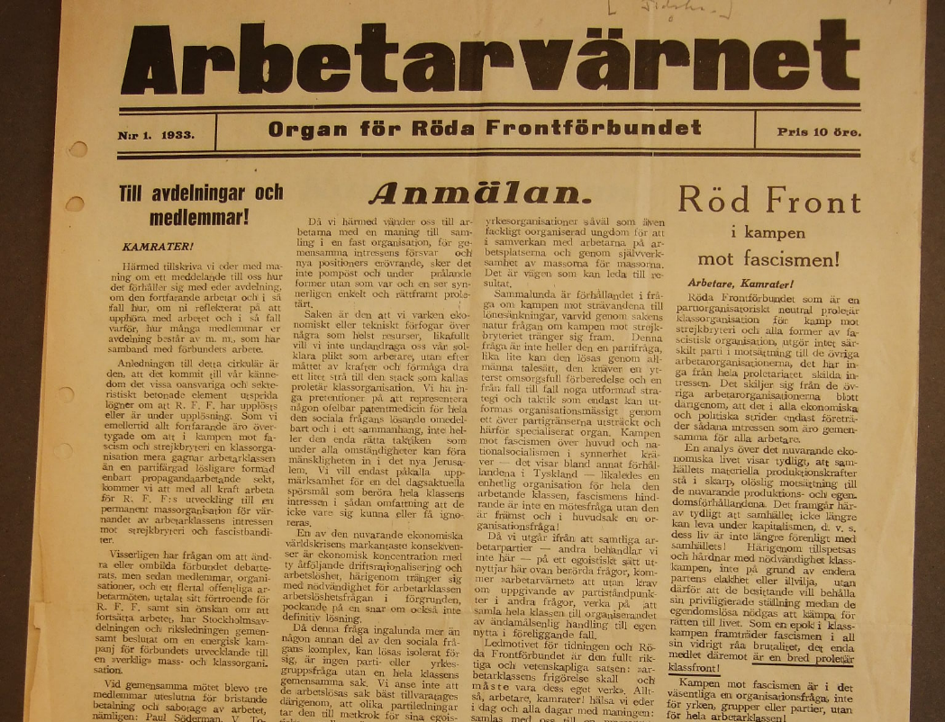
The association’s newspaper “Arbetarvärnet (Worker’s Guard)” 1933.
These comrades were expected to form the front line in the class struggle, which at that time meant physically confronting the police at demonstrations, attacking strike breakers, and defending against fascists. Compared to Germany, the Swedish Nazi movement was more limited, but this did not stop the union from attacking Nazi events, including during the Easter riots in Uppsala in 1943, where the police actively defended the Nazis and attacked anti-fascists with drawn sabers.
The Nazis also attempted to attack communists on several occasions, including the attack on Ny Dag in 1931. On the evening of February 7, three Nazi youths attempted to enter the premises under the pretext that they had founded a youth club in Sickla and wanted to meet Hugo Sillén, who was in the building. When they were welcomed into the premises, they pulled out revolvers and pointed them at Fritjof Lager, who was responsible for youth affairs at SKU, but what they did not know was that Hugo Sillén, Spanish Civil War veteran Knut Olsson, editor Gustaf Johansson, and worker Lindbeck were in the room next door. Lindbeck had just been in Chicago, where he had gained experience in fighting the gangster violence that was attempting to attack the trade unions there. As a result, he was hardly a man who hesitated to use violence.
Without firing a single shot, Lindbeck disarmed the Nazis. With one hand, he twisted the arm of one Nazi out of its socket, then with his other hand forced the other Nazi to drop the second revolver. Fritjof Lager was no longer threatened by any revolver, whereupon he struck one of the Nazis, who reportedly “collapsed like a sack of potatoes.”
The result of this incident was not any greater condemnation of the Nazis’ violent actions. The three hooligans received only suspended sentences, and the following years saw only harsher repression against communists in Sweden. A few years after the incident, Norrskensflamman was also attacked and unable to defend itself, resulting in five deaths.
The leadership of the SKP had already been infiltrated by a rightist faction that would pave the way for social democracy in Sweden through cooperation after a major election victory in 1944, and it was precisely this same leadership that did not see the need to further develop the Red Front Association and its revolutionary potential. The association was later dissolved in 1933 in an attempt to tone down the revolutionary image of the SKP. Furthermore, the reaction from the state under the coalition government was an offensive against the legal rights of communists. In 1940, among other things, a transport ban on the communist press was decided, and comrades continued to be victims of house searches and arrests without evidence. Ny Dag described this situation succinctly as: “The police dictatorship has prevailed.”

The development of armed resistance during World War II
Throughout this period, the bourgeois forces were incredibly incompetent when it came to “fighting fascism.” Often, they were incompetent because they themselves were trying to develop fascism, while in other cases it was led by the private faction within the imperialist bourgeoisie, which in most cases was weaker than the state-monopolistic faction during this period. Today, all parties seem to claim that they were part of the anti-fascist resistance, but what did this resistance entail? The only work they did was parliamentary, which could hardly stop the fascist forces. In many cases, they collaborated with the fascists in parliament, precisely in order to limit the work of the communists. As communists, we know that there are clear reasons for this, since fascism only functions as a higher stage of the dictatorship of the bourgeoisie.
Once Nazism had seized power, it was already too late for these legalists and pacifists to mount any resistance. And subsequently, the main resistance to the Nazis was of a revolutionary nature. When we see how war swept across Europe, it is almost impossible to find any kind of “peaceful” successful action. While some liberal groups spent their time printing leaflets, the growing partisan movement emerged as the main resistance to Nazism behind the front lines.
Across Europe, people took up arms to crush fascism, including in Italy, Yugoslavia, the Soviet Union, Poland, France, Albania, and, on a smaller scale, Norway and Denmark. In both Yugoslavia and Albania, the partisans succeeded in liberating entire countries and kicking out the fascists.
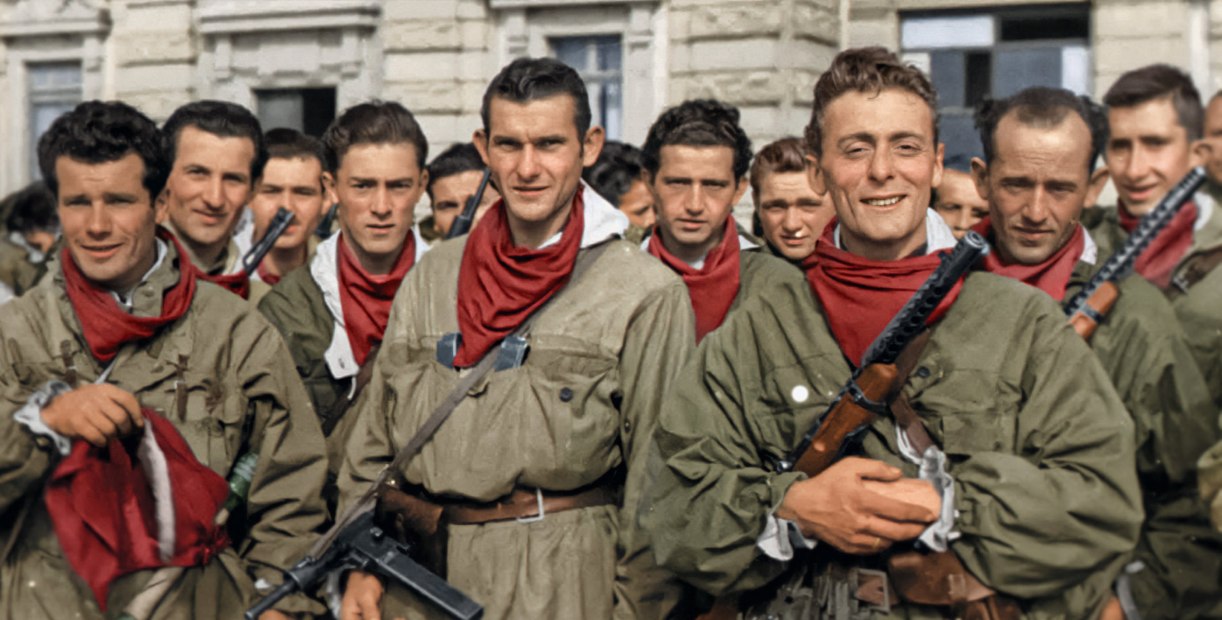
Italian Partisans, 1945.
Although the bourgeois state wants to promote ideas of “peaceful” and “pacifist” politics within the framework of the law, this particular issue is something that they can never convey in any other way than to say: The combined strength and armed struggle of the people throughout the world, led by the CPSU, is the reason for the defeat of the Nazis in World War II.

The postwar period
The defeat of the fascists during the war did not mark the end of their history. During this period, the economy was able to recover and began to grow again. This also meant that the reactionary tendencies within the bourgeois state that characterized the period between the First and Second World Wars were temporarily reversed. During this period, the fascists were able to rebrand themselves as democrats and thus regained prominent positions within the bourgeois state. For example, Adolf Heusinger, who was elected in 1938 to the Oberkommando des Heeres (OKH), the highest command of the German army in Nazi Germany from 1936 to 1945, later became a lieutenant general in 1955 when West Germany’s armed forces, the Bundeswehr, were formed. In 1957, he was appointed the Bundeswehr’s first Inspector General, equivalent to Chief of Defense, a position he held until 1961. In April 1961, he was appointed chairman of NATO’s Military Committee in Washington, D.C., and held that position until 1964. In Sweden, for example, the royal family was able to continue living as usual despite its obvious support for and connections to the Nazis during the war. The same applies to monopoly capitalist families such as the Wallenbergs, who earned large sums of money in the Nazi economy, or Tage Erlander, who was responsible for imprisoning communists and class-conscious workers in labor camps and was rewarded with Sweden’s longest premiership to date, as well as countless others in the Swedish army, intelligence services, and state bureaucracy, who continued to climb the career ladder after the war.
During this period, there was also no need for fascist storm troops. Although there were large communist parties in Europe that had previously fought armed struggles, which later turned to revisionism, as well as later large mass parties guided by Mao Zedong Thought, there were no armed threats to the bourgeois state apparatus, which made the parties relatively toothless. The practices of these parties mimicked the tactics of many parties before World War I, where theories of accumulation of power were on the agenda, as well as a passion for seats in parliament, which made the parties harmless and even proof of “Western democracy” that could let these parties into the fold.
Fascism emerges with crisis or under the threat of proletarian revolution. The economic base always shapes the thoughts and ideas that are entrenched in the superstructure. It is crisis that activates discontent among the people, which parts of the bourgeoisie try to channel against the people by building up the fascist movement. It is therefore not surprising that when imperialism entered its general crisis in 1980, which had its origins in the stagnation of the 1970s that triggered the so-called “neoliberal” policy with the dismantling of welfare and outsourcing at the top of the agenda, various new fascist violent sects began to emerge on the old continent.

“Neo-fascism”
From 1945 to 1980, the Nazi movement was very limited in Sweden, but it nevertheless managed to survive, mainly among the upper echelons of the bourgeoisie and the Swedish nobility. The main organization during this period was the Nordic Reich Party (NRP). It never had a large membership and only received around 150 votes in general elections.
However, something that lives on from this period is the famous photograph of “The Woman with the Handbag” from 1985, which shows Danuta Danielsson attacking a Nazi with her handbag. What most people don’t know is the whole story behind the incident. The NRP had been granted permission to demonstrate in Växjö but was met with widespread resistance from the entire city. The VPK had organized a counter-demonstration, which succeeded in gathering thousands of ordinary Swedes against the Nazis’ small group of only about ten people.
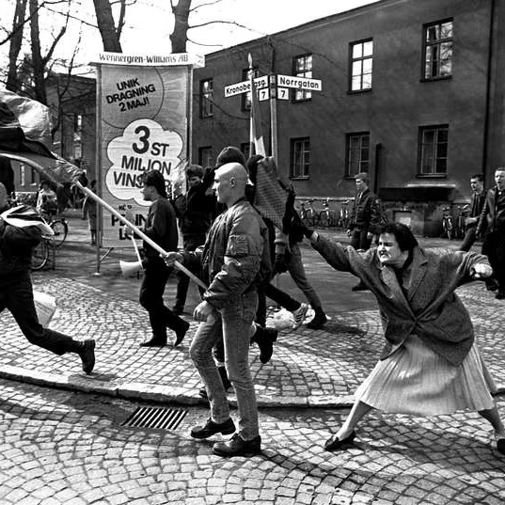
Videos from the incident show ordinary people—a group of workers, pensioners, and even people with baby carriages—engaging in direct physical confrontation with the Nazis and managing to chase them away. One of the Nazis was even knocked unconscious. Eventually, the Nazis ran all the way to the train station, where they were forced to seek shelter in the restrooms.
Once again, people took to the streets to show their anger and contempt for Nazism. This event proves once again that the main tool against fascism is not open peaceful debate with these scumbags. The only language these Nazis speak is violence, and when people use violence, the Nazis’ only choice is to run away.
Link to a video from the confrontation: Sweden: Fight between the Communist party and nazis -1985
However, by the 1990s, fascism began to grow stronger again in Sweden. This period saw two major groups in particular pose a real threat: the White Aryan Resistance (VAM) and later the National Socialist Front (NSF).
VAM was mainly present among a growing scene of boneheads (an alleged offshoot of skinheads) and attempted to build a subculture around white power music. They followed a global trend of using skinhead culture to recruit members to their Nazi organizations. These organizations existed all over the world and increasingly used violence against anti-fascists and others they saw as enemies. In several countries, these groups became outright terrorist organizations that indiscriminately murdered innocent people, mainly immigrants but also left-wing activists. One example is the NSU group in Germany.
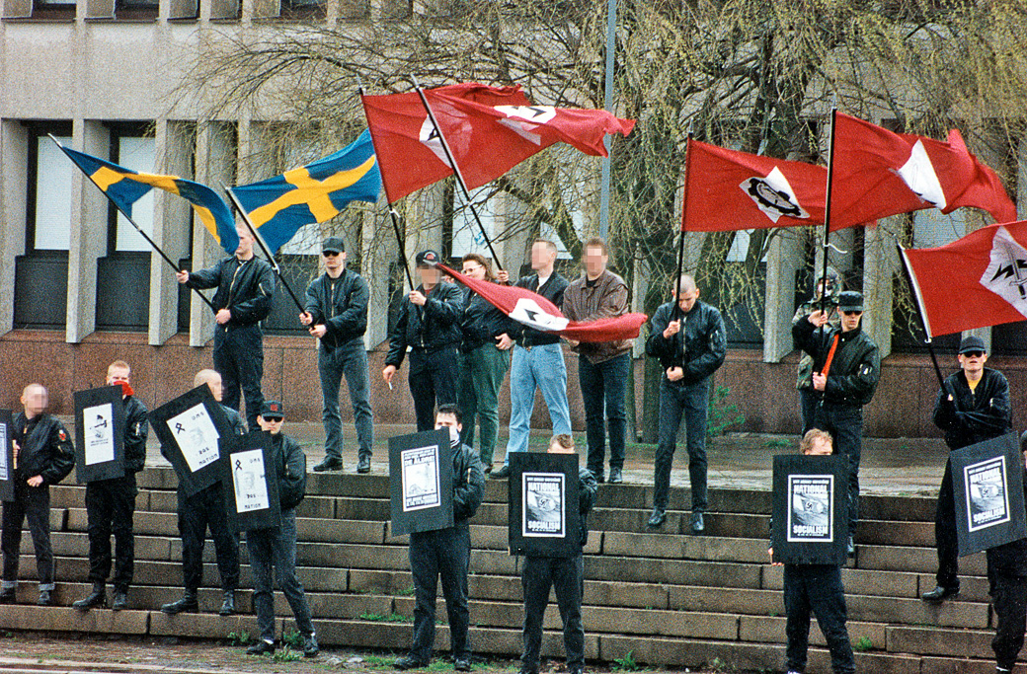
VAM in Göteborg, 1992.
In Sweden, VAM was the first group of this type to become relevant, and carried out several bomb threats against public places, including Åhléns and Arlanda. In addition, they were present at several street fights during the 1990s, often side by side with the Sweden Democrats. However, VAM did not become a long-lasting organization, but began to fall apart after its leaders were convicted of crimes and chose to end their activities in 1993.
NSF was founded in 1994 in Karlskrona, inspired by VAM. This organization grew relatively large and was not only active on the streets, but also chose to arm itself in preparation for “the coming race war.” On several occasions, they looted weapons depots belonging to both the Swedish Armed Forces and the police. These weapons were later used to commit several robberies, including the famous case in Malexander, where three Nazis from NSF robbed a bank of 2.6 million kronor and later fled from the police. When they came to a stop, one of the Nazis shot the two police officers who fell down, later executing them with shots to the neck. These men were all sentenced to life imprisonment.
This period thus points to a Nazi movement that was increasingly violent and did not hesitate to commit murder. According to Expo, 48 people were murdered as a result of Nazi violence between 1983 and 2019.
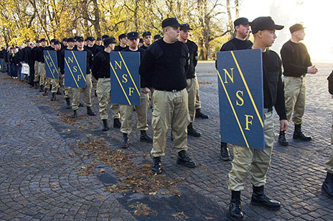
NSF in Jönköping, 2005.
One of the more well-known cases of Nazi violence was the murder of trade unionist Björn Söderberg in 1999. Björn was a member of SAC and had exposed Robert Vesterlund as a Nazi while he was on the board of the Handels trade union at his workplace. After the information came out, Robert was removed from his position and resigned from his job. The following month, three Nazis began threatening Björn over the phone, and eventually went to his home with a gun, where they confronted Björn and shot him several times. The incident led to large demonstrations with up to 20,000 people in Stockholm. In memory of Björn Söderberg, the Civil Courage Award is still presented to trade union heroes today.

What means shall we employ?
Something that distinguishes the growing anti-fascist movement in Sweden during this period is its political base. The earlier anti-fascist movement during the interwar period and World War II was essentially always led by the communist parties affiliated with the Comintern. Anti-fascism was always part of the many tasks carried out by the Communist parties and was fought for the purpose of seizing power in their own countries or defending what was at that time the world’s only socialist state. These organizations had a clear understanding of what fascism is, and with this analysis, they could see the clear truth that the bourgeois state was always the main enemy, and it was only through the state that fascism developed and was unleashed as a weapon against the proletarian movement.
Without a communist party, a spontaneous anti-fascist movement emerged. The spontaneous movement, as Lenin teaches us in What Is to Be Done? (1902) and as history has proven, is never able to unite the spontaneous struggle into a struggle for political power. This requires that the struggle serve a greater goal than the one immediately at hand, and ultimately serve to build a force capable of tearing down the old state and building a new one. This requires a conscious force, willing, principled, and capable of building this movement—a communist party.
Without communist leadership, its spontaneous movements will at best be radical petty-bourgeois movements, regardless of the class of the participants in the movement, because it does not serve the class interests of the proletariat to put an end to a society based on exploitation. At best, these movements can make capitalism more tolerable by chasing away a few Nazi pigs, but in doing so they only serve to preserve society as it is and do the work of the bourgeois democrats for them.
The growing autonomous movement in Sweden led to the founding of Antifascist Action, which also followed a global trend of growing anti-fascist resistance without communist leadership. One of the first major battles took place in Lund in 1991. November 30 is known as the celebration of the “warrior king” Charles XII, and commemorative celebrations had been held at his statue since the 1880s. But during the 1980s, the commemoration took on an increasingly fascist character, and a sight that became more and more common was the Nazi flags that adorned the streets of Lund. A number of activists then decided to prevent these Nazis from coming to the city, and in 1991 this culminated in incredibly large counter-demonstrations with a united front of anti-fascists who refused to let the Nazis march through the city. The counter-demonstrations continued every year until the Nazis simply stopped holding the march.
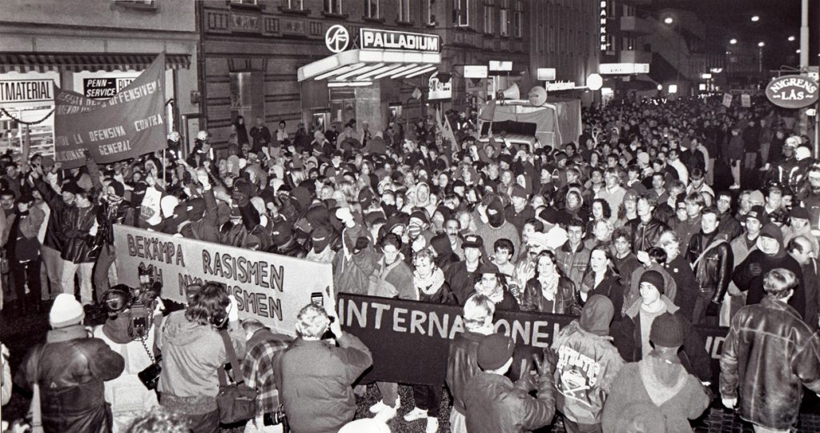
Antifascist counter-demonstration in Lund, 1991.
On November 30, the Nazis attempted to establish a holiday where they could gather forces and parade through cities, including Stockholm. But the collective resistance of the people forced the Nazis to retreat for fear of being beaten and stopped. Something that reflects these large demonstrations is the fact that the Nazis rarely gathered more than 100 people, while anti-fascists gathered thousands. It is in this climate that anti-fascism gained greater attention. On this particular issue, two groups emerged as more radical and successful, offering important experiences, both good and bad, as well as many lessons for communists and revolutionaries.

Antifascistisk Aktion
AFA developed into a nationwide organization in 1993 and began to take up the fight against fascists in new ways. In addition to using traditional methods such as putting up posters and distributing flyers, it also built up an intelligence structure to map fascist organizations and their members. Among other things, it managed to hack the website of the Nazi publishing house Nordiska Förlaget in 2004 and gained access to a customer register of 1,500 people and secret plans for a new organization. They continued to expose frequently identified Nazis in an attempt to raise public awareness and inform their workplaces that these individuals were organized Nazis. A similar attack was carried out against the Midgård publishing house in 2023, where the customer register was also published for the general public, which was also used by anti-fascists globally.
In addition to intelligence work, there was always a strong emphasis on violence as a tool against Nazism. From 1993 to 2012, there were numerous violent confrontations not only against Nazis, but also against Christian Democrats and the Migration Agency. Some of these actions include:
- Arson attack on EU election booths during the 1994 vote
- Riots and stone throwing against Nazis in Trollhättan in 1996
- Arson attack on the National Alliance’s office in 1996
- Riots and stone throwing against Nazis in Linköping in 1997
- Large-scale brawl against Nazis in Gävle on New Year’s Eve 2000
- Arson attack against the NSF headquarters in 2005, which was classified as murder by arson
- Attack against the SD’s National Day celebrations in 2006 in Växjö, armed with baseball bats
- Vandalism of the Christian Democrats’ premises in Kalmar for their “anti-worker attacks” in 2006
- Axe attack on a judge in the Migration Agency in Gothenburg in 2007
- Postering and exposure of a Nazi in Uppsala, where 500 kronor and a free knuckle duster were offered to anyone who managed to assault the named Nazi.
- Assault on a National Democratic politician in Hagsätra in 2009, which was classified as attempted murder
- Participation in the Rosengård riots in 2009.
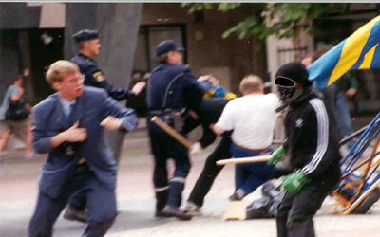
For the first time, the movement succeeded in countering Nazi violence by launching its own offensive against the fascist movement. This led several of the victims to seek empathy in the mass media, and most media outlets now began to focus on condemning this violence, instead seeking “consensus and dialogue” with these Nazis.
Due to its tendency to use violence, AFA also became a focus for SÄPO, which investigated and probably attempted to infiltrate the organization. In several reports, SÄPO mentions their organization as a leader in the autonomous movement and that AFA actively maps and attacks people from the white power movement and even politicians within the Sweden Democrats. The fear and hatred of AFA lives on among the Sweden Democrats to this day, and Charlie Weimers has even proposed that AFA be classified as a terrorist organization, similar to what Trump has done in the United States.
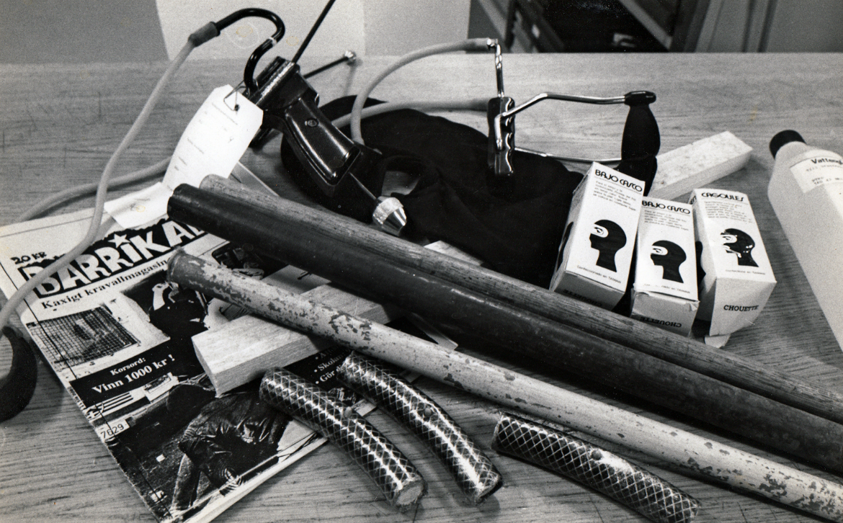
Material confiscated from an antifascist by the police in Malmö, 1994.

Revolutionära Fronten
Something that permeated the entire so-called left during this period was a kind of subculture, where one’s individual lifestyle was often placed as an important focus, sometimes weighing more heavily than one’s actual practice. This was strongly criticized by those who went on to found the Revolutionary Front (RF), who themselves came from backgrounds in the suburbs around the major cities.
The culture that existed among many left-wing groups was seen as elitist and petty bourgeois, isolating and excluding many who came from a proletarian background. Because of this, it was considered necessary to build a new organization from the ground up, with roots in the suburbs and also in football communities.
AFA was not seen as capable of going all the way, and RF began its work by trying to build up a greater capacity for violence than any other left-wing group had done before. However, the group functioned primarily as a “buddy group” and did not focus much on expanding to other cities, but rather remained limited to Örebro and Gothenburg in its early days.
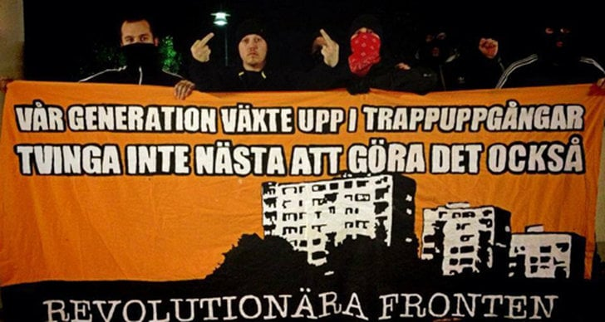
Rapper Sebbe Staxx from the group Kartellen together with RF, 2013.
However, the organization matured over the years and new branches were opened in Stockholm, among other places. A sense of discipline was built up among members, who now dared to take on the Nazis even when they were outnumbered. Word of the RF’s strength began to spread, and they gained a certain popularity among the rest of the left, who now actively sought out the RF to ask them to act as security at demonstrations.
However, the political level was not a priority, and the organization had a relatively low level of unity on ideological/political issues. There was no significant work on studying, and political discussions took place mainly informally, with the departments differing in their ideological positions. Of course, the majority were active in other projects on the side, where politics took up more space. However, three points of unity were put forward: socialism, internationalism, and anti-fascism.
The RF carried out a wide range of activities, including joint training sessions, soccer tournaments, and other sporting events. It seems to have continued to be centered around groups of friends who were very close to each other and had a very strong loyalty that is not always found in the political environment. RF was also active in participating in trade union blockades against several workplaces and also participated in a number of house occupations around Sweden.
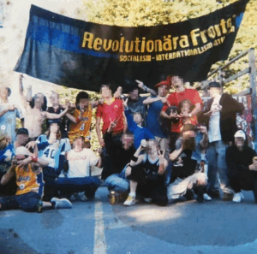
Baseball tournament, early 2000s
Violent confrontations with Nazis were nothing new in Sweden, but RF undeniably took it a step further during its lifetime. Through its website, it filmed attacks targeting individual Nazis, including breaking into their homes and vandalizing entire properties. Other times, they confronted Nazis on the street and went straight to attack, often armed with weapons.
With advanced media knowledge, these videos were published and later spread throughout Sweden, even being shown on television during prime time. The conservative press tried to paint a picture of violent hooligans attacking innocent people, and relatively often failed to mention that the individuals they attacked were organized Nazis. At the same time, this became a great inspiration for ordinary people across the country, especially among young people from the suburbs.
The old revisionists began to criticize RF, arguing that they simply went too far in their methods and that they had no right to challenge the state’s monopoly on violence. Among others, Jonas Wikström wrote the following in Flamman in 2014:
” The problem with violence is that it appeals on a completely different level than the rational one: it gives a feeling of “doing something.” And you get that if you skip the tough class struggle and go straight for the symptoms—the autonomists are thus a kind of upside-down left wing. This is also evident in their uncomfortably harsh view of the often-young boys who make up the groups of Nazis and racists. As if, in this particular case, there were no social circumstances, only a black hole of evil.”
Instead, the parliamentary parties believed that dissatisfaction with racism should be demonstrated by “turning one’s back” on the SD, and in certain, more confrontational situations, by “rattling one’s keys.”
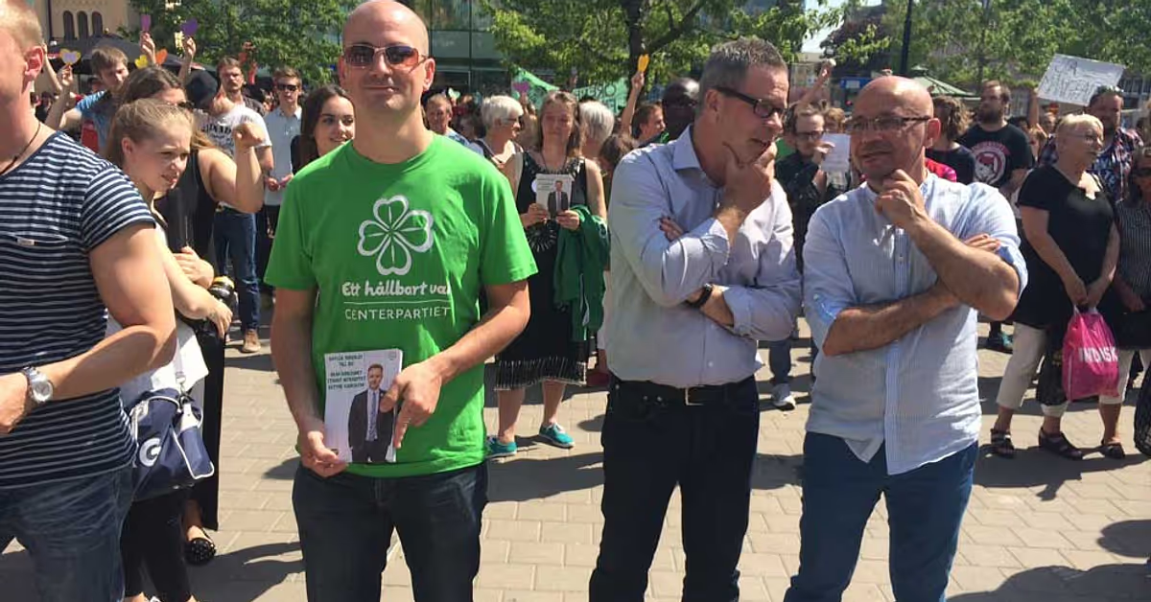
Municipal politicians from V and C “turn their backs” to SD, 2014.
Despite everything, RF received an incredible amount of attention, further in a report from Uppdrag Granskning in 2014 and also in a documentary from American Vice in 2014, which has received millions of views.
Link to the Vice documentary: The Rise of Sweden’s Far-Left Militants
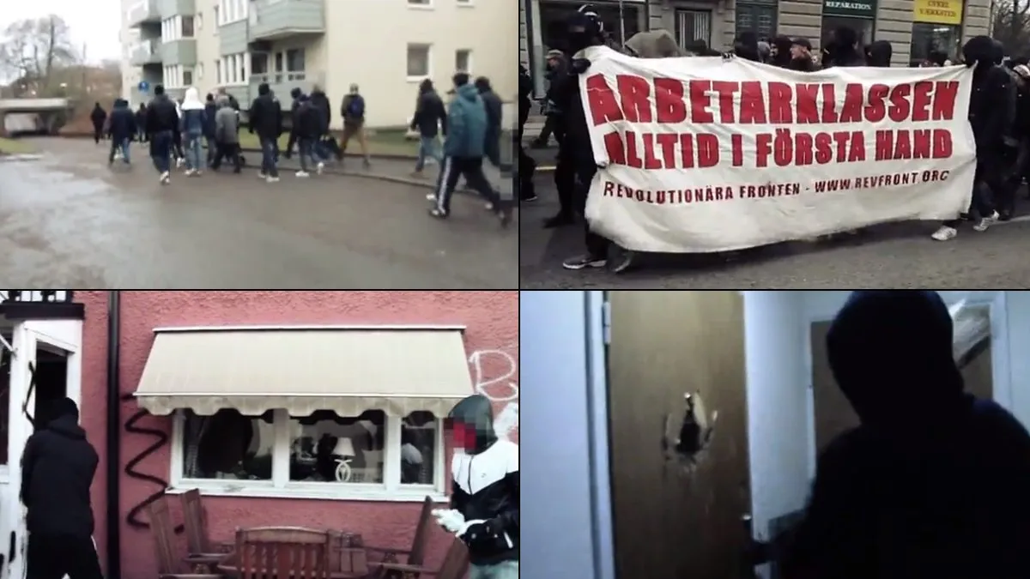
Actions carried out by RF.
This method of searching for Nazis everywhere, even in their own homes, led to widespread fear among the organized Nazi movement. The largest Nazi organization at the time, the Swedish Party (formerly NSF), was so affected by the fear among its own members that the party chose to disband in 2015, citing a “lack of membership.”
However, the consequence of this militant anti-fascism was a repression much stronger than we had seen in a long time. Most members were convicted in major trials over the years. One of the more famous cases involved a member who defended a demonstration march in Kärrtorp in 2013, when he stabbed one of the Nazis who had tried to throw glass bottles at the peaceful march. He was sentenced to 6 years and 6 months in prison, but then became the subject of a broad campaign for his freedom across Europe.
In November of the same year, the police also launched “Operation Eskil,” which involved raiding several RF members, confiscating materials, and arresting eight people. The police brought along reporters from Aftonbladet who were present during the raids to film and photograph the arrests in an attempt to further discredit the organization.
In conversations with members of the movement, several stated that the harsh repression was a major reason for their closure in 2015. After SVP announced its closure, RF also began to consider closing down. In September, a post was published on their Facebook page informing about the closure.
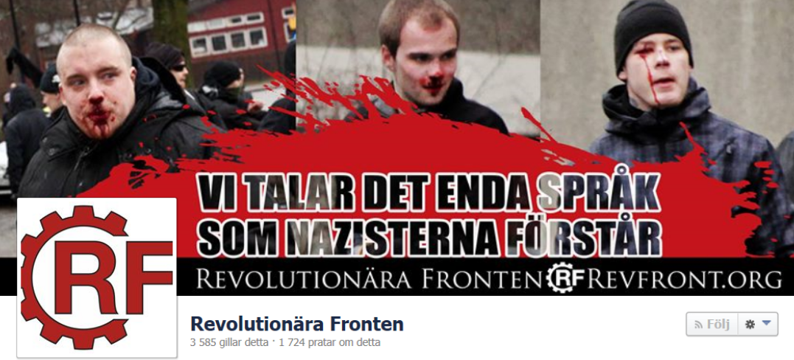
RF was outwardly a more radical version of AFA, but its political content was the same. The enemy, as formulated in both theory and practice, continued to be “the fascists”; no struggle was waged against the bourgeois state or its other political tools, such as the liberal, reformist, and revisionist parties. This meant that even though RF waged a more intense struggle against fascist gangs and mobilized more proletarian elements than AFA managed to do, the struggle against the imperialist system and its apparatus of violence in Sweden—the bourgeois state—was not waged. In addition, ideological/political development was neglected, which meant that it was unable to build an organization that could cope with increased reactionary forces.
Both RF and AFA once again highlight the importance of carrying out the communists’ main task of reconstituting the Communist Party. This party must understand the class struggle in Sweden, its balance of power, which masses it should appeal to, which struggles can be transformed into armed struggle to initiate a revolutionary war, a war of the masses, a people’s war against the bourgeois state, and build a new power in its vacuum. All struggles that remain within the framework of the system only prolong its life. Even if the struggle is illegal and uses violence, its content remains system-preserving because it does not target the core of the bourgeois dictatorship—its state apparatus and armed forces.
At the same time, it is important never to throw the baby out with the bathwater. Both AFA and RF show how it is possible to mobilize the masses for armed confrontations and actions, how it is possible to build up illegal apparatus in an imperialist country like Sweden, they offer many valuable military maneuvers and show how the people themselves can build up large and effective intelligence operations.

The situation today?
The bourgeois state and its parties always condemned anti-fascist violence and often portrayed anti-fascists as “the real threat.” Today, bourgeois politicians and self-appointed experts argue that “left-wing violence” is worse than “right-wing violence,” especially violence from the Palestinian movement, which over time has become increasingly passive and peaceful in its actions, with the aim of increasing repression against its opponents.
The general crisis in the world is worsening day by day with the process of imperialist decay, where the exploitation of the working people is constantly increasing, reactionary forces are intensifying, and militarization is escalating in preparation for a coming imperialist war of redistribution. All this has an impact on social consciousness. Without a conscious force, fascists will win over large sections of the masses with their “criticism of the system,” and it is therefore inevitable that so-called “right-wing extremist violence” will become more and more commonplace.
While everything has been done to pacify the anti-fascist movement, the Nazis have grown stronger. Some believed that the Nazis were defeated when the Swedes’ Party was dissolved in 2015, but as Marxists, we know that these movements are expressed in ideas born out of material conditions that live on and are not only expressed in a few small organizations.
Today, there are a number of “far-right” organizations in Sweden, which are largely much weaker than before, but at the same time, a new type of fascist organization is emerging, mainly among Aktiv Klubb. Like the subcultural bonehead movement, Aktiv Klubb is part of a global network of Nazis who collaborate with each other and seem to focus primarily on training for future confrontations with their “enemies.” Last year’s attack in Gubbängen can probably only be seen as a starting point for this movement’s future goals. With discreet ties to the government, this organization is yet another attempt to attack the growing communist movement. These scumbags will not hesitate to attack people when they get their chance, and at a time when we lack an anti-fascist movement with a similar capacity for violence, the situation will only get worse.
However, we must not fall into the trap of seeing only these small groups as the fascist movement. These vandals are merely foot soldiers for the bourgeoisie’s fighting organization. While they do the dirty work through physical confrontations, it is the parliamentary parties that pave the way for fascism within the state apparatus.
Yes, the establishment of fascism as a form of government is not a question of “if” it will happen, but a question of when. With a united cross-bloc line, the question remains: Who will carry out this reactionary shift? Will it ultimately be the Sweden Democrats who, like Mussolini, succeed in “tricking” the bourgeois and liberal parties into a coalition government, or will it once again be the Social Democrats, possibly with support from the Left Party, who become the leading force in curbing the proletarian class struggle? We will discuss this in future articles.
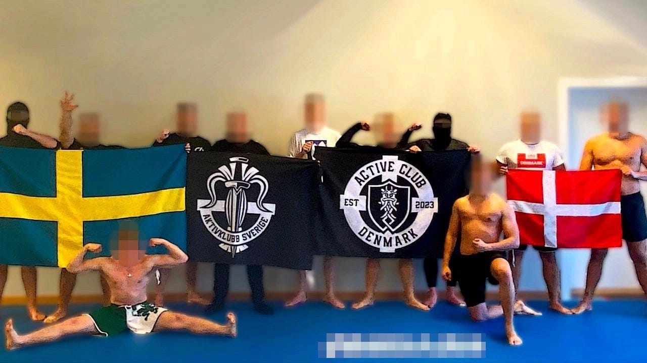

What is revolutionary violence?
Revolutionary violence is not just any kind of violence. Marx said that “violence is the midwife of every old society pregnant with a new one.” Revolutionary violence is thus the means by which progressive forces change the world. Lenin stated that “the replacement of the bourgeois state by the proletarian state is impossible without a violent revolution.” This means that revolutionary violence must be directed against the bourgeois state. Mao Zedong continued, stating that “the central task and highest form of revolution is the seizure of power by armed force, the resolution of disputes by means of war. This Marxist-Leninist principle of revolution applies universally, to China and to all other countries.” Thus, violence must be prepared to be resolved through war, which means the need for extremely disciplined organization and determination. This requires, since the enemy is strong and we are weak, that we must rely on the masses, who are the majority and who will benefit from the change, and incorporate them into the revolutionary war.
Revolutionary violence must serve the goal of building a new society and must therefore be directed against the old state with the aim of destroying it and establishing a new monopoly on violence. The fundamental difference between revolutionary violence and violence in general is whether it serves the proletariat’s struggle for political power, for the dictatorship of the proletariat based on an armed force led by the Communist Party.
The bourgeoisie’s class interest is to preserve the current imperialist world order and consolidate private property and wage slavery for all time. In other words, the workers want to liberate humanity from all forms of oppression and exploitation, while the bourgeoisie wants to consolidate a system in which a few live like parasites on the masses. The working class is therefore fighting a war to advance humanity toward a realm of abundance, while the bourgeoisie is fighting its war to preserve the rotten existing order.
By committing violence that does not threaten, or even have the intention of threatening, the foundations of the old society, it thus becomes a violence that preserves the current imperialist world order, where private property, wage slavery, and imperialist wars continue.
To carry out violence only against one faction of the bourgeoisie, the fascist part, and to reconcile with the bourgeois democratic part, turns violence into bourgeois democratic violence that defends the interests of one faction of the bourgeoisie and serves its purposes. To use violence only against fascist violent sects and not against the bourgeois state apparatus does not mean that the violence is revolutionary, but rather that it serves to legitimize the current order and makes capitalism more “tolerable.” The idea spread to the masses is that the fascists are bad, but the other bourgeois politicians are tolerable and can therefore be reconciled with.

What is required by the antifascist struggle?
By analyzing fascism, understanding its character and essence, we understand that the only way to avoid a new Nazi Germany is through revolution. In other words, the struggle against the bourgeois state system, that is, against the state, is the only method for removing this cancer from humanity. Turning the gun on its useful idiots, its pathetic stormtroopers, is like bailing water out of a boat with a hole in the hull; it only alleviates the symptoms but does not solve the cause.
The fundamental issue in proletarian ideology is the question of political power, and thus only the struggle for political power can resolve this issue. This can only be achieved through revolutionary violence. Whether violence is revolutionary or not depends on who you direct it against. The same applies to the sailors on the sinking boat. The only problem-solving approach is to try to fix the cause of the sinking by repairing the hull, and no matter how good the intentions of the sailors bailing water out of the boat may be, they are not part of the problem-solving force and are therefore a useful tool for those who want to see the boat sink to the bottom of the sea.
The so-called anti-fascist movement arises spontaneously, and it is important to transform its insight—that fascism must be fought with violence—into consciousness: that fascism is only an expression of bourgeois dictatorship and that it is this dictatorship that must be crushed in order to guarantee a world without oppression, which can only be done through the establishment of a new state, which crushes the old one, under the leadership of a communist party. This highlights the need to build a communist platform that can spread awareness among all progressive elements and organize them to serve the process of reconstituting the Communist Party of Sweden. This is the work that Kommunistiska Föreningen has undertaken to accomplish.
Kontakta oss via Kommunisten@riseup.net!

Prepared by Maoism Library from https://kommunisten.nu/?p=16759

