Report on Fulfillment of the National Economic Plan of the People's Republic of China in 1955
With Statistical Summary
ISSUED BY
the State Statistical Bureau of the People's Republic of China

Printed in the People's Republic of China
1965

REPORT ON FULFILLMENT OF THE NATIONAL ECONOMIC PLAN IN 1955
APPENDICES: STATISTICAL SUMMARY
- POPULATION
- TOTAL OUTPUT VALUE OF INDUSTRY AND AGRICULTURE
- TOTAL OUTPUT VALUE OF INDUSTRY ACCORDING TO ECONOMIC SECTORS
- NUMBERS OF INDUSTRIAL ENTERPRISES
- TOTAL OUTPUT VALUE OF INDUSTRY
- OUTPUT OF CHIEF INDUSTRIAL PRODUCTS
- STATE INVESTMENT IN CAPITAL CONSTRUCTION IN VARIOUS BRANCHES OF NATIONAL ECONOMY
- AREA OF FARMLAND
- AREA SOWN TO STAPLE CROPS
- OUTPUT OF STAPLE CROPS
- NUMBERS OF LIVESTOCK
- OUTPUT OF TEA, SILKWORM COCOONS AND AQUATIC PRODUCTS
- STATE FARMS UNDER THE MINISTRY OF AGRICULTURE
- MECHANIZED FARMS UNDER THE MINISTRY OF AGRICULTURE
- GROWTH OF AGRICULTURAL PRODUCERS' MUTUAL-AID AND CO-OPERATIVE ORGANIZATIONS
- NUMBERS OF AGRICULTURAL PRODUCERS' CO-OPERATIVES
- COMMUNICATIONS, TRANSPORT, POSTS AND TELE-COMMUNICATIONS
- PROPORTION OF FREIGHT MILEAGE HANDLED BY PUBLIC AND PRIVATE COMMUNICATION AND TRANSPORT ENTERPRISES
- PROPORTION OF COMMODITY RETAIL SALES HANDLED BY PUBLIC AND PRIVATE ENTERPRISES
- WHOLESALE AND RETAIL SALES IN COMMERCIAL ORGANIZATIONS
- WHOLESALE PRICE INDEX NUMBERS
- NUMBERS OF STUDENTS
- NUMBERS OF STUDENTS IN HIGHER EDUCATIONAL INSTITUTIONS
- NUMBERS OF STUDENTS IN SECONDARY VOCATIONAL SCHOOLS
- CULTURAL INSTITUTIONS AND PUBLICATIONS
- PUBLIC HEALTH SERVICES
- LABOR INSURANCE AND FREE MEDICAL TREATMENT

REPORT ON FULFILLMENT OF THE NATIONAL ECONOMIC PLAN IN 1955
ISSUED BY the State Statistical Bureau of the People's Republic of China
June 14, 1956

Profound changes took place in China's national economy in 1955. Because of the heavy floods of the preceding year, the growth of various branches of the national economy in general, and of light industry and retail trade in particular, was somewhat slower than in previous years. After the sixth plenary session of the Central Committee of the Communist Party of China, at which Rightist, conservative ideas were criticized and rectified, hundreds of millions of Chinese peasants, responding eagerly to the call of the Chinese Communist Party and Chairman Mao, brought about an upsurge in the socialist transformation of agriculture. This was followed, in swift succession, by a high tide in the co-operative organization of handicrafts and the change-over of capitalist industry and commerce, by whole trades, to joint state-private operation. As a result, the national economy reached new heights. The situation in the main branches of the national economy in 1955 is summarized below:

1. GROWTH OF INDUSTRIAL PRODUCTION, IMPROVEMENT OF INDUSTRIAL TECHNIQUES AND THE SOCIALIST TRANSFORMATION OF PRIVATE INDUSTRY
The main features of industrial production in 1955 were as follows. Production in heavy industry continued to show a marked rise, while production in light industry was somewhat slower owing to the inadequate supply of raw materials provided by agriculture. As compared with 1954, production of capital goods rose by 17 percent, and that of consumer goods by only 1 percent.
In 1955 the total value of the nation's industrial output (the term as used here and later does not include output of handicrafts organized on a co-operative basis and individual handicrafts) was 101 percent of the figure set in the state plan; and within this the state-owned industrial enterprises produced 108 percent of the planned figure. The various industrial ministries fulfilled their output-value plans to the following extent:

Ministry of Power Industry | 102%
Ministry of Coal Industry | 104%
Ministry of Petroleum Industry | 109%
Ministry of Heavy Industry | 106%
First Ministry of Machine-Building Industry | 110%
Ministry of Textile Industry | 101%
Ministry of Light Industry | 106%

As compared with 1954, the total value of China's industrial output in 1955 rose by 8 percent. By categories, the growth in 1955 as compared to 1954 was as follows:
State-owned Industry | 15%
Co-operative-run Industry | 35%
Joint State-Private Industry | 41%

The total output value of private industry dropped by 30 percent, the main reason being that many more private industrial enterprises came under joint state-private operation.
In 1955 state plans were fulfilled or overfulfilled for 37 of the 45 major industrial products included in the Five-Year Plan. Plans for the remaining eight were not fulfilled. Of this 45, the output of 31 (not counting two which had not been produced in 1954) exceeded the 1954 level. The output of the remaining 12 fell below the 1954 level owing to limited supplies of raw materials, to the fact that they did not meet the requirements, or in other cases to underestimation of demand. (The number of metal-cutting machine tools produced was less, but their aggregate tonnage more.)
The output of the twenty principal industrial items is given below:
Item | Unit | Absolute Figures for 1955 | Percentages Compared with 1954
Electric Power | 1,000,000 kwh. | 12,278 | 112
Coal | 1,000 tons | 93,604 | 117
Crude Oil | 1,000 tons | 966 | 122
Pig Iron | 1,000 tons | 3,630 | 123
Steel | 1,000 tons | 2,853 | 128
Steel Products | 1,000 tons | 2,505 | 128
Soda | 1,000 tons | 405 | 130
Ammonium Sulphate | 1,000 tons | 324 | 109
Cement | 1,000 tons | 4,503 | 98
Electric Generators | 1,000 kilowatts | 108 | 197
Metal-cutting Machine Tools | number | 13,708 | 86
Locomotives | number | 98 | 188
Freight Wagons | number | 9,258 | 170
Double-wheeled Double-shared Ploughs | 1,000's | 523 | 873
Cotton Yarn | 1,000 bales | 3,968 | 86
Cotton Cloth | 1,000,000 bolts | 103 | 84
Motor-car Tires | 1,000's | 593 | 85
Paper | 1,000 tons | 589 | 106
Sugar | 1,000 tons | 410 | 118
Cigarettes | 1,000 crates | 3,567 | 96
Further technical improvements were made in industrial production in 1955. Various industrial ministries succeeded in the trial manufacture of many new products. The following are some major items:
Large-scale power equipment including 10,000-kilowatt automatic turbo-generators and water turbines, 6,000-kilowatt steam turbines, and boilers with an evaporation rate of 40 tons an hour;
Heavy equipment for mining and metallurgy, including sintering machines capable of dealing with 90 tons of ore an hour, axial blowers with a diameter of 2.4 meters used in shafts, and coke-oven rams;
Metal-cutting machine tools, 59 new types including universal slotting machines and single-spindle automatic lathes;
Farm machinery and implements, including combine harvesters, 48-row seeders and five-shared ploughs;
Steel products including heavy steel rails weighing 50 kilograms per meter, seamless alloy steel tubing for use in the petroleum industry, many kinds of alloy steel, special steel shapes for the manufacture of motor-cars, silicon steel sheets for electric motors, and steel plates for shipbuilding.
Advanced ways of working were adopted in many industrial departments in 1955. Major technical indices all rose somewhat as compared with 1954. The consumption of standard coal to generate one kilowatt-hour of electricity fell by 2.4 percent; the extraction rate of coal rose by 4 percent: mechanized coal-cutting at the coal face rose by 16.8 percent; the utilization rate of blast furnaces increased by 7.9 percent; the utilization coefficient of open-hearth furnaces increased by 17.7 percent. Consumption of raw materials per unit was reduced in the manufacture of cotton yarn, cotton cloth, rubber products and cigarettes.
Production costs in state industrial enterprises administered by the various industrial ministries and in locally-administered state key industries fell by 8 percent in 1955 as compared with 1954. As a result of the growth of production and the reduction of costs, the various industrial ministries overfulfilled the targets set for profits in 1955 by 10 per cent. Some enterprises, however, failed to grasp the meaning of all-round economy; they economized too much on raw material, caring only for quantity of output and ignoring quality.
As a result of the transformation of capitalist industry into joint state-private industry by whole trades in 1955, there was a continued growth in the proportion of the total industrial output (by value) produced by socialist and semi-socialist industry. Of the total value of China's industrial output in 1955, 63 per cent was produced by state industrial enterprises, 5 per cent by co-operatively run industry, 16 per cent by joint state-private industry and 16 per cent by private industry. In private industry, 82 per cent of the total value of output consisted of goods processed, ordered, distributed or purchased by the state.
The organization of handicraft co-operatives continued to develop in 1955. The number of handicraft producers' co-operative organizations reached 64,000 with a membership of 2,200,000; they embraced 29 per cent of all handicraftsmen, as against 15 per cent in 1954. The total value of their output was about 72 per cent more than in 1954. The total value of the output of individual handicrafts (that is, excluding those which had become organized) dropped by 13 per cent of the 1954 figure.

2. THE GROWTH OF AGRICULTURAL PRODUCTION AND THE SOCIALIST TRANSFORMATION OF AGRICULTURE
The year 1955 was marked by a giant stride in the socialist transformation of agriculture. Once Rightist, conservative errors with regard to co-operative farming had been corrected, agricultural producers' co-operatives grew by leaps and bounds. About 630,000 such co-operatives shared in the distribution of the autumn harvest. By the end of the year there were over 1,900,000, embracing more than 75 million peasant households, or about 63 percent of all those in the country. The area of land under collective cultivation grew to over 1,000 million mou, or about 64 percent of the total cultivated area. Of the cooperatives, more than 17,000 were fully socialist. They embraced over 4,700,000 households, and cultivated over 82 million mou of farmland.
In 1955 there was a splendid harvest. The total yield of food crops was about 368,000 million catties (184 million tons), a figure representing 102 percent of the state plan. The total crop was 9 percent greater than in 1954. Production of cotton reached some 30,360,000 piculs (1,518,000 tons), fulfilling the 1955 plan by 117 percent and exceeding the 1954 crop by 43. Taking 1954 as 100, the output of staple crops in 1955 was: rice 110, wheat 98, coarse grains 111, soya beans 100, sugar-cane 94, sugar-beet 161, jute 195, cured tobacco 128, rape-seed 110, groundnuts 106.
Tea production was up by 17 percent compared to 1954, and coconuts by 44 percent. Staple fruit crops — apples, pears, oranges and tangerines, bananas and grapes — were about 10 percent heavier than in 1954.
The 1955 yield per mou of agricultural producers' cooperatives in all major crop-growing areas was strikingly higher than that of individual peasants' land. The difference was 10 percent for rice, 7 percent for wheat, 19 percent for soya beans and 26 percent for cotton. This bears out fully the advantages of cooperative farming.
Alongside the speedy growth of the agricultural cooperative movement, socialist state farms also made further progress in 1955. The number of mechanized state farms reached 106. They cultivated 4,040,000 mou of land, 45 percent more than in 1954.
In 1955, tractor stations in China numbered 138, and they served over 4,900,000 mou, four times as much as in 1954.
The capacity of irrigation pumps in China, in terms of horsepower, was 24 percent greater in 1955 than in 1954, and they irrigated over 8,300,000 mou. Major irrigation works built by the state and minor ones built or repaired locally extended the nation's total irrigated area by 19 million mou, while irrigation facilities were improved on over 46 million mou.
Some 13 million mou of land were reclaimed in 1955.
In animal husbandry, the 1955 plan was not fulfilled owing to the inadequate supply of fodder and improper steps taken in dealing with the draught animals which the peasants pooled in the co-operatives. A survey made at the end of June in 1955 showed that the number of cattle increased by 4 percent compared with the same period of 1954, of horses by 5 percent and of sheep and goats by 4 percent. The number of pigs went down somewhat.
In fisheries, mutual aid and co-operation developed rapidly in 1955. The number of fishing co-operatives rose to more than 7,600. Compared with 1954, the total output of aquatic products increased by 10 percent. For state fishing enterprises alone the increase was 14 percent.
The total afforested area of the country in 1955 was over 25,600,000 mou, or 47 percent more than 1954. Over 14,200,000 mou were timber areas and 5,900,000 mou shelter-belts. Of the trees planted during the year, however, only 64 percent survived.
Relief funds allocated by the government to rural areas in 1955 totaled over 200 million yuan. Farm loans amounted to more than 1,000 million yuan.
Meteorological services also made progress in 1955. Compared with 1954, the number of meteorological observatories and stations increased by 40 percent.

3. GROWTH OF CAPITAL CONSTRUCTION
In 1955, the state invested 8,630 million yuan in capital construction. This was 94 percent of the planned amount and 9 percent more than the comparable amount in 1954. Owing to reduced unit cost, the actual amount of capital construction was 15 percent greater than in 1954; the amount of building and installation work increased by 18 percent. New increases in fixed assets, as a result of investment, made up 86 percent of the total investment.
As compared with 1954, the actual amount of industrial construction increased by 27 percent, and investments in industrial construction accounted for 48 percent of the total state investment. Work was started or continued on 485 above-norm projects in 1955, and 82 went into production. The chief ones completed were: the Tungsan vertical shaft of the Hokang Mining Administration, the Chungyang vertical shaft of the Liaoyuan Mining Administration, the Hsiaohengshan vertical shaft in Chihsi, the Shenyang No. 1 Machine-Tool Factory, the Dairen Power and Heat Station, the Wulapo Hydroelectric Power Station, the Paotow Sugar Refinery, the Kiamusze Sugar Refinery, the Peking No. 2 Cotton Mill, the Shihchiachwang No. 2 Cotton Mill, the Chengchow No. 3 Cotton Mill and the "July 1" Cotton Textile Factory at Urumchi.
Capital construction in 1955 in the fields of transport, posts and telecommunications was 27 percent greater than in 1954. A total of 1,222 kilometers of new railway track was laid. Along the Lanchow-Sinkiang Railway, 24.8 percent of track-laying was completed in 1955; along the Paochi-Chengtu Railway, 73 percent. New main lines opened to traffic included the Chining-Erhlien, Litang-Chanchiang, Fengtai-Shacheng and Lantsun-Chefoo Railways. A total of 8,138 kilometers of highways was built, including the Chengtu-Nga Ba and Shigatse-Gyangtse Highways, now open to traffic, which are of great help to the economic and cultural development of national minority regions. The Phari-Yatung Highway, which runs through the Himalayas, was nearly completed.
In agriculture, forestry and water conservancy, the amount of work done in 1955 was 65 percent greater than in 1954. Water conservancy construction alone involved over 1,400 million cubic meters of earthwork and more than 14 million cubic meters of stonework, while 600,000 cubic meters of concrete were laid. The Nanwan Reservoir was, in the main, completed.
Construction of public utilities in 1955 increased by 9 percent as compared with 1954. Housing built by the state totaled over 14 million square meters of floor space.
A movement for greater economy was launched in capital construction departments. Standards were lowered in designing non-productive buildings. Statistics for 3,280 fairly large construction jobs show that more than 1,000 million yuan were economized on them — a 16.1 percent reduction of the planned investment. The goals set by the state in the reduction of building and installation costs were accomplished in the main.
The amount of geological prospecting done in 1955 was 40 percent greater than in 1954. Discoveries by the geological departments of deposits of the principal minerals such as oil, iron, manganese, coal, tungsten, copper, lead and phosphorus, all exceeded those found in the year before. Great strides were made in geological reconnaissance in 1955, but this work still lagged far behind the demands of prospecting.

4. DEVELOPMENT OF TRANSPORT, POSTS AND TELECOMMUNICATIONS; SOCIALIST TRANSFORMATION OF PRIVATE TRANSPORT
A total of 26,931 kilometers of railways was open to traffic in 1955. Railway freight in ton-kilometers increased by 5 percent over 1954. The utilization rate of locomotives and wagons was higher.
Freights transported by steamer, barge and motor vehicle in 1955 (in ton-kilometers) increased as follows: for inland shipping by 32 percent, coastal shipping by 4 percent, for motor vehicles by 35 percent.
The socialist transformation of private transport enterprises was carried out in 1955. Apart from railways and civil airlines, which are wholly run by the state, shipping run by the state and under joint state-private operation handled 98 percent (in ton-nautical miles) of total shipped freights. In motor transport, vehicles under state and state-private and co-operative ownership handled 82 percent of all freights (in ton-kilometers).
The volume of business handled by the post and telecommunication services in 1955 exceeded that of 1954 by 13 percent. The number of main post and telecommunication offices and branch offices increased by 34 percent, and the number of postal and telegraph agencies was reduced by 18 percent as compared with the end of 1954.

5. GROWTH OF DOMESTIC AND FOREIGN TRADE; SOCIALIST TRANSFORMATION OF PRIVATE COMMERCE
Due to the floods of the previous year, domestic trade expanded rather slowly in 1955; total domestic retail sales were only 3 percent greater than in 1954.
State trade overfulfilled its purchase plan for 1955. As compared with 1954 (taken as 100), state and co-operative purchases of the principal farm products used for industrial raw materials were as follows: cotton, 151; cured tobacco, 136; jute for gunny sacks, 209; vegetable oil, 120.
State trade failed to fulfill its sales plan for 1955. But compared with 1954 (taken as 100), its domestic sales of major commodities were as follows: cotton cloth, 108; sugar, 123; edible oil, 157; pork, 134; cigarettes, 90; coal, 111; bicycles, 139; paper, 118; towels, 116; and hosiery, 115. The total value of means of production sold to the peasants by supply and marketing co-operatives was 23 percent greater than in 1954.
In spite of the fact that the output of grain increased somewhat in 1955 as compared to 1954, the state reduced its purchases of grain, and in the calendar year of 1955 the total was 10 percent less than in 1954. This enabled the peasants to retain more grain after the harvest. State sales of grain during the year decreased, as compared to 1954, by 2 percent.
In 1955, the volume of sales by state shops in the national minority areas was 41 percent higher than the 1954 volume.
The number of state and co-operative commercial organizations increased by 9 percent in 1955 as compared with 1954.
In 1955, the state was active in effecting socialist transformation of private trade. Of all wholesale trade in commercial organizations, 95 percent was handled by state and co-operative commerce in 1955 as against 89 percent in 1954. Retail sales by state, co-operative and state-capitalist commerce in 1955 accounted for 82 percent of the national total in commercial organizations, as against 74 percent in 1954.
Commodity prices remained stable throughout the country during the period under review. Taking December 1954 as 100, the national wholesale price index in December 1955 was 99.9. The index for retail prices in eight cities — Peking, Shanghai, Tientsin, Wuhan, Canton, Chungking, Sian, and Shenyang — was 100.7.
China continued to expand economic co-operation with the Soviet Union and the People's Democracies in 1955; and trade relations with Asian-African and Western countries were further developed.

6. NUMBER OF WORKERS AND OFFICE EMPLOYEES, PRODUCTIVITY OF LABOR, WELL-BEING OF WORKERS AND OFFICE EMPLOYEES
In 1955, various offices and enterprises throughout the country took steps to simplify their organization and economize in the use of labor. At the end of 1955 there were still over 18,500,000 workers and employees throughout the country — an increase of more than 200,000 over 1954.
In 1955, various industrial ministries trained more than 96,000 skilled workers. In addition, more than 377,000 workers and managerial personnel improved their vocational skill at schools or in training courses.
In 1955, the productivity of labor of workers in state, co-operative and joint state-private enterprises increased by 10 percent as compared with 1954. Separate increases were: 8.2 percent in the fuel extractive industry, 16.3 percent in the iron and steel industry, 15.7 percent in the non-ferrous metals industry, 12.9 percent in the engineering industry, and 15.2 percent in the chemical industry. The productivity of workers in enterprises connected with building and installation increased by 17 percent compared with 1954.
In 1955 the average wages of workers and employees throughout the country, excluding those in private enterprises, increased by 3.9 percent as compared with 1954. Owing to the increase of average wages and employment of new workers and office employees, the total wage bill was 12 percent higher than in 1954.
In 1955 a great number of workers and office employees in state organs who had been on the "supply system" went over to a wage basis. The wages of the lower ranks of employees in state organs whose pay had been fairly low, and of those working in commercial, cultural and educational departments, were adjusted. Wage increases were greater in these categories. The wages of workers and employees in industry and the departments responsible for capital construction, on the other hand, increased only slightly. Their real wages, in some cases, even dropped. This was attributed to the fact that certain irrational awards had been abolished, a rational system of merit awards had not been established, and wage scales were not adjusted in time. Another reason was that workers in certain departments received less because of enforced idleness and stoppage of work.
In 1955, workers and office employees in enterprises covered by labor insurance numbered 6 percent more than in 1954. The number entitled to free medical care increased by 5 percent as compared with 1954.

7. ACHIEVEMENTS IN CULTURAL, EDUCATIONAL AND PUBLIC HEALTH WORK
Further achievements were made in 1955 in cultural, educational and public health work.
Students in higher educational institutions numbered over 290,000 in 1955, an increase of 13 percent over 1954. Students attending secondary vocational schools totaled 537,000, a drop of 12 percent compared with 1954. The drop was due to underestimation of the need for medium-grade technical personnel, and particularly to the improper reduction of the enrollment of new students in normal schools.
In 1955, more than 200,000 people attended spare-time higher educational institutions and spare-time secondary vocational schools.
Over 56,000 students graduated from higher educational institutions in 1955, an increase of 18 percent over 1954. Thirty-three percent of them graduated in engineering. Over 235,000 students, 39 percent more than in 1954, finished secondary vocational schools. All are now working in national construction.
Students attending middle schools in 1955 numbered 3,900,000, an increase of 9 percent over 1954. The number of students who passed through senior middle schools was 99,000, an increase of 46 percent over 1954. Primary schools had 53,100,000 pupils, exceeding the 1954 figure by 4 percent. There were over 560,000 children in kindergartens, an increase of 16 percent over 1954.
A total of 2,670,000 students from the national minorities attended various schools in 1955. The seven colleges for nationalities had an enrollment of over 6,000 students.
Following the advance in agricultural cooperation, some 50 million peasants joined spare-time literacy classes in 1955. Over 2,840,000 workers and office employees in factories and mines also joined such classes.
In 1955 the Chinese Academy of Sciences had 44 research institutes with a research staff 27 percent larger than in 1954.
Hospital and sanatorium beds in China in 1955 numbered over 279,000, 12 percent more than in 1954.
The clinics cooperatively run by groups of doctors and other joint clinics numbered over 30,000 in 1955. This was 23 percent more than in 1954.
Doctors of Chinese traditional medicine played a more active part in public health work in 1955. Ninety thousand of them joined publicly operated health institutions or cooperatively run joint clinics, which was 27 percent more than in 1954. Many medical workers in China began to carry on systematic research into the rich legacy of Chinese traditional medicine. The Academy of Chinese Medicine was set up by the state.
More and more people participated in sport in 1955, which greatly raised the standard of athletics. In that year, national records were broken 384 times.
Films produced in 1955 numbered 112, but only 18 were full-length feature films. A total of 136 foreign films was dubbed in Chinese. Over 5,800 film projection units were active throughout China, 19 percent more than in 1954. Cinema audiences were 20 percent greater than in 1954.
In 1955, there were 285 national and local (provincial, municipal and administrative regional) newspapers, and their total annual circulation was 14 percent more than in 1954. There were 370 magazines, and their total annual circulation increased by 41 percent compared with 1954.
Over 22,000 books were published in 1955. The total number of copies printed was 15 percent more than in 1954. Of these books, over 1,000 were in the languages of the national minorities, an increase of 4 percent over 1954.
In 1955, China had over 6,300 cultural centers, large and small.
The power of broadcasting transmitters throughout the country increased by 48 percent compared to 1954.

APPENDICES
Statistical Summary

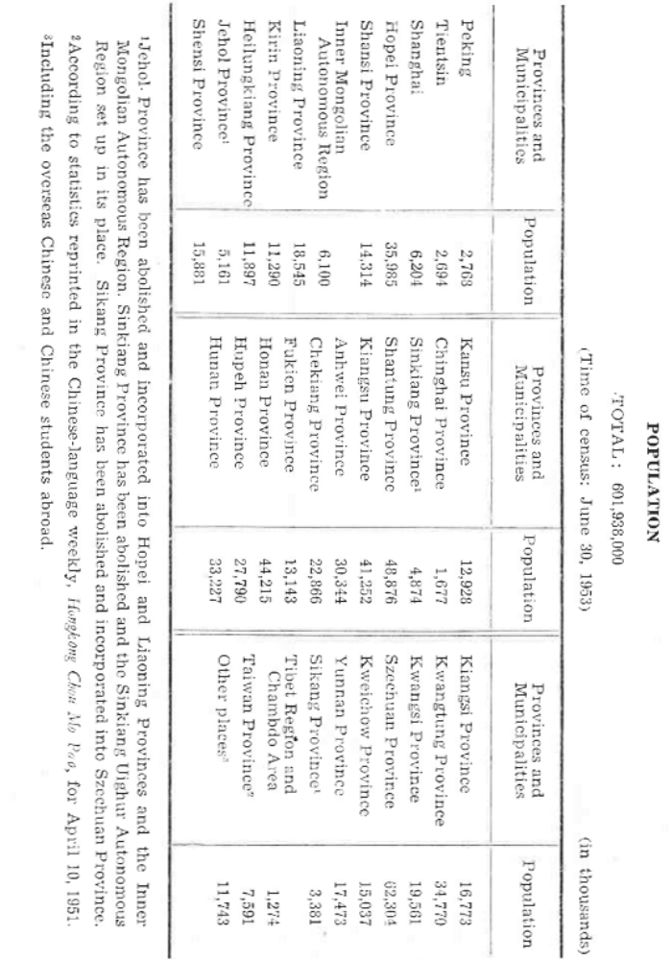
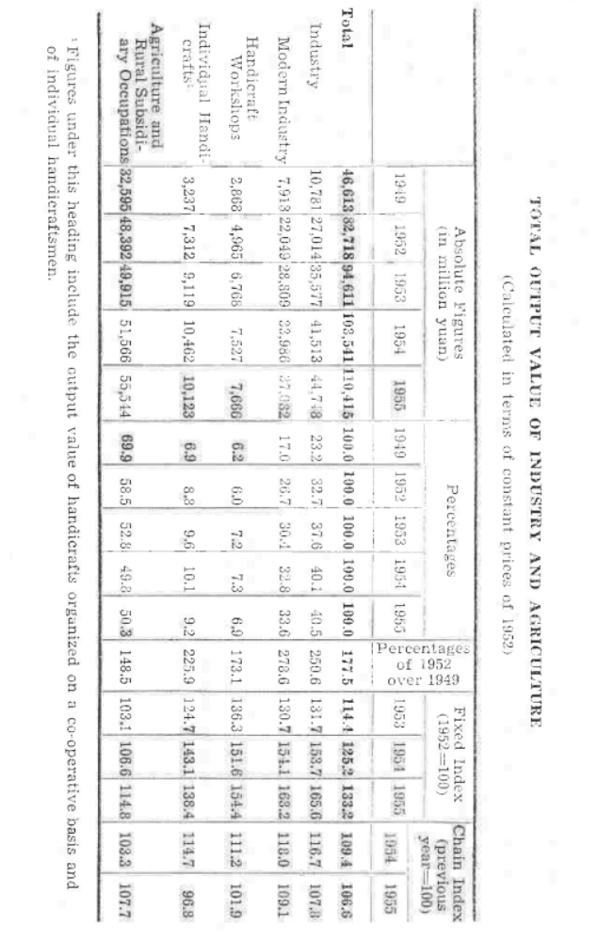
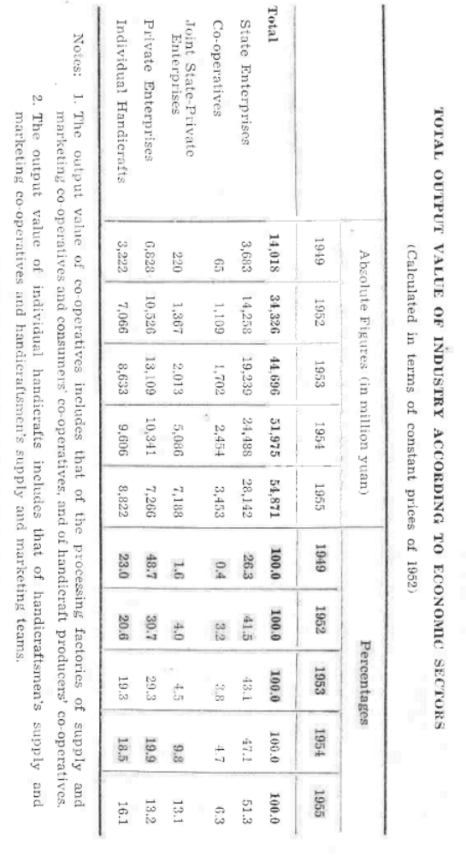
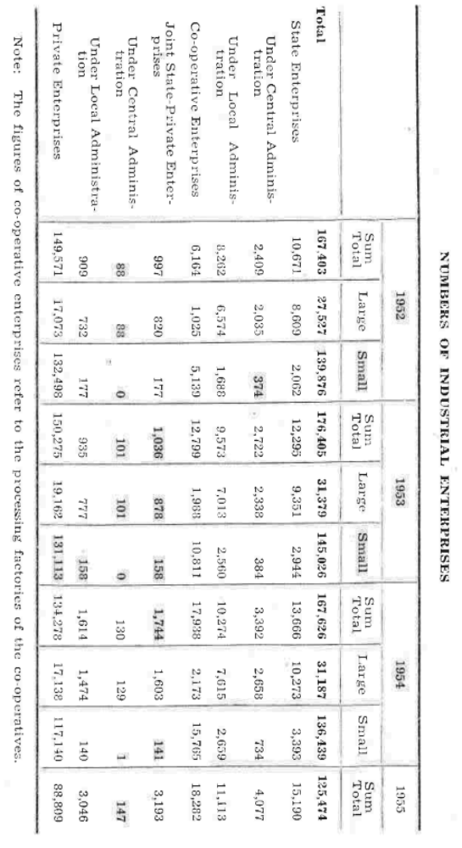
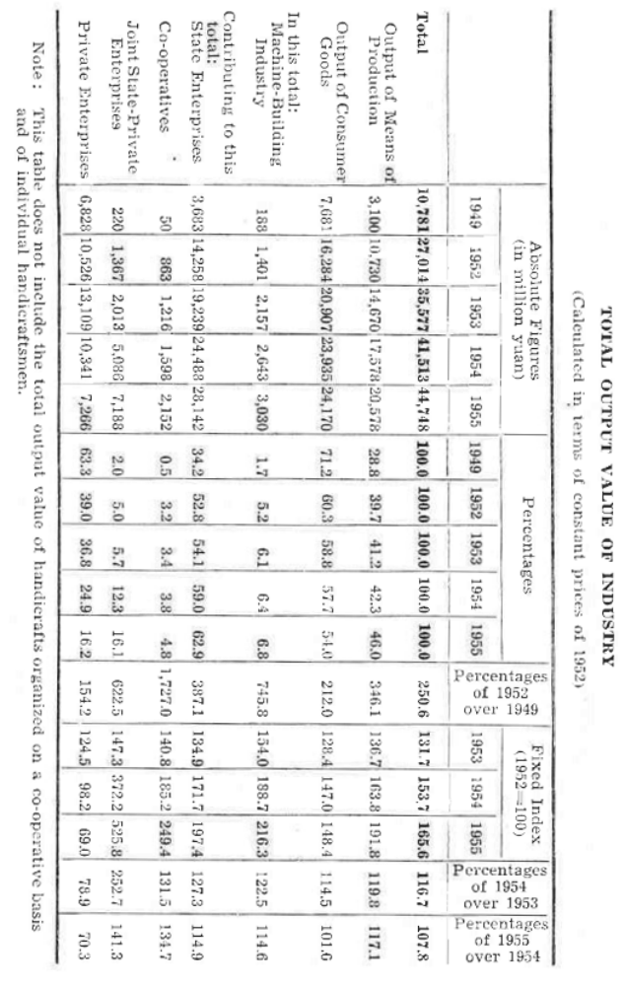
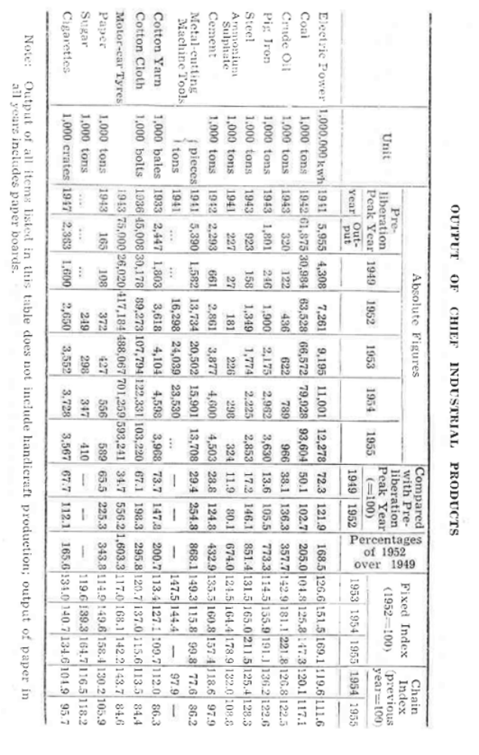
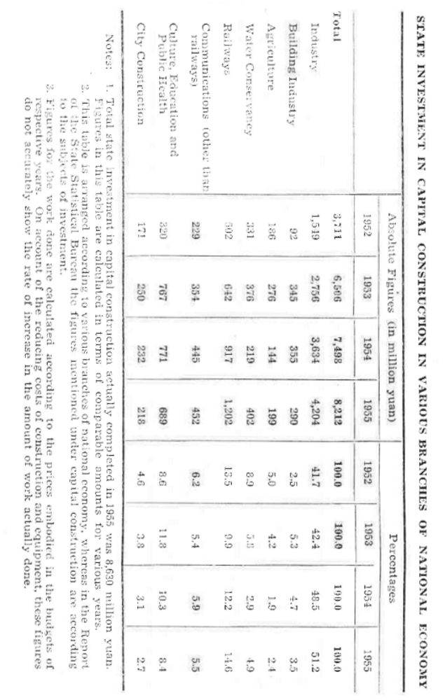
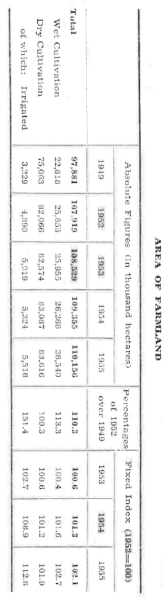
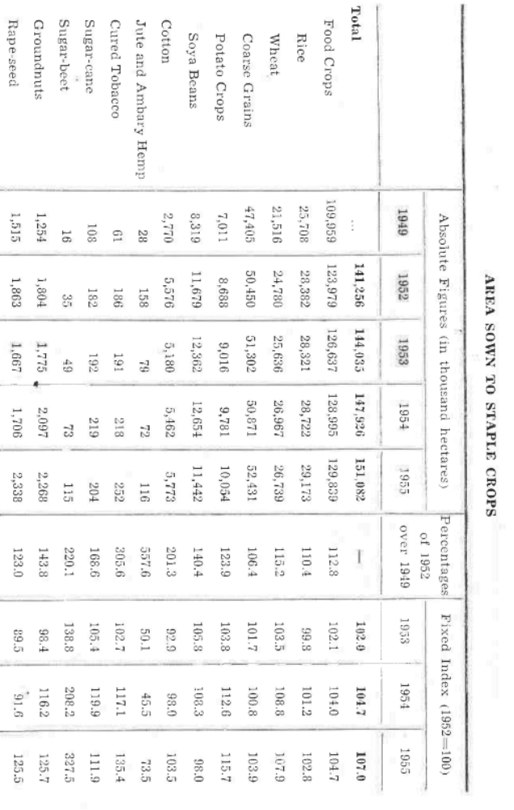
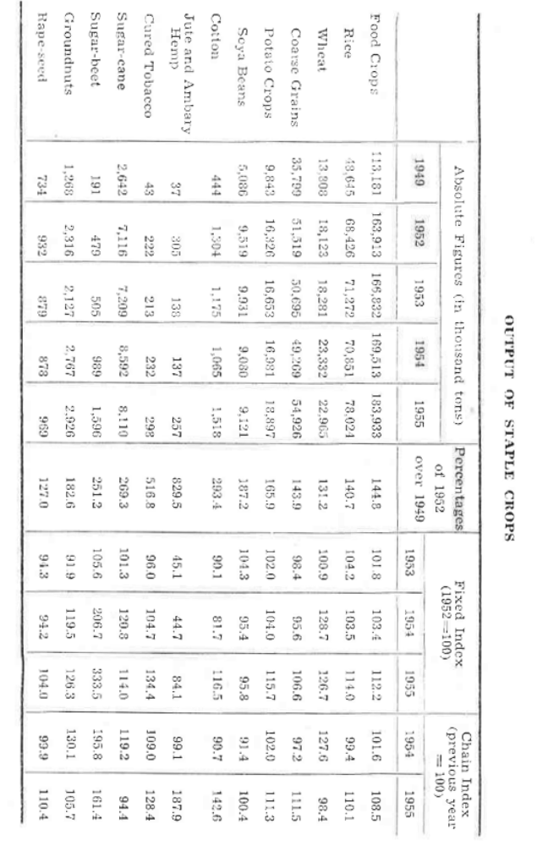
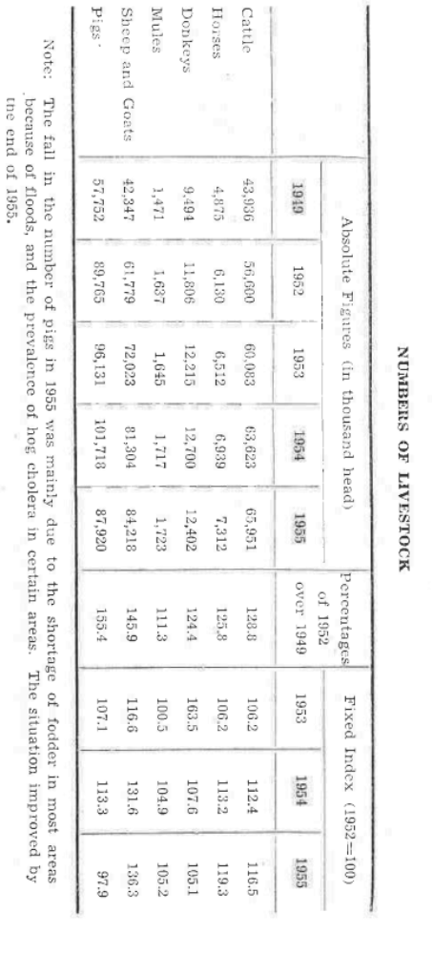
OUTPUT OF TEA, SILKWORM COCOONS AND AQUATIC PRODUCTS
Product | Absolute Figures (in thousand tons) |  |  |  |  | Percentages of 1952 over 1949 | Fixed Index (1952=100)
 | 1949 | 1952 | 1953 | 1954 | 1955 | Percentages of 1952 over 1949 | 1953 | 1954 | 1955
Tea | 41.1 | 82.4 | 84.7 | 92.1 | 108.0 | 200.7 | 102.8 | 111.8 | 131.0
Cocoons (domestic silkworms) | 30.9 | 62.2 | 59.3 | 65.1 | 67.0 | 201.3 | 95.2 | 104.6 | 107.7
Cocoons (tussah) | 11.9 | 61.1 | 12.3 | 25.7 | 63.8 | 513.5 | 20.1 | 42.1 | 104.5
Aquatic Products | 447.9 | 1,666.3 | 1,899.7 | 2,293.5 | 2,517.9 | 372.0 | 114.0 | 137.6 | 151.1
Note: The production of tussah cocoons is mainly concentrated in Liaoning Province where there was a good yield in 1952, but output fell in 1953 and 1954 due to natural calamities.

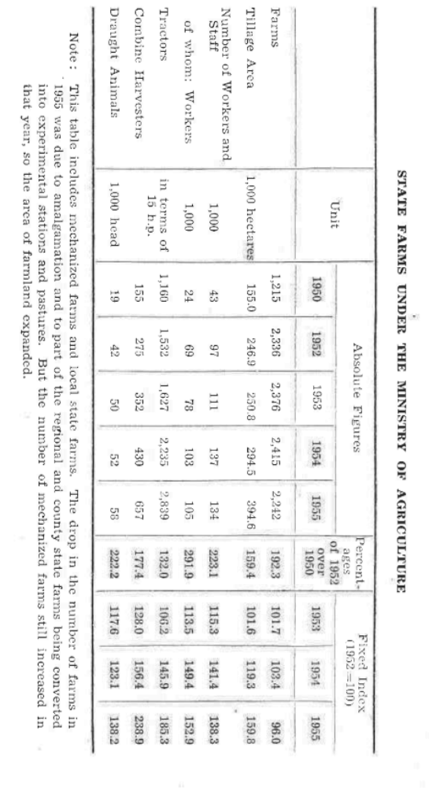
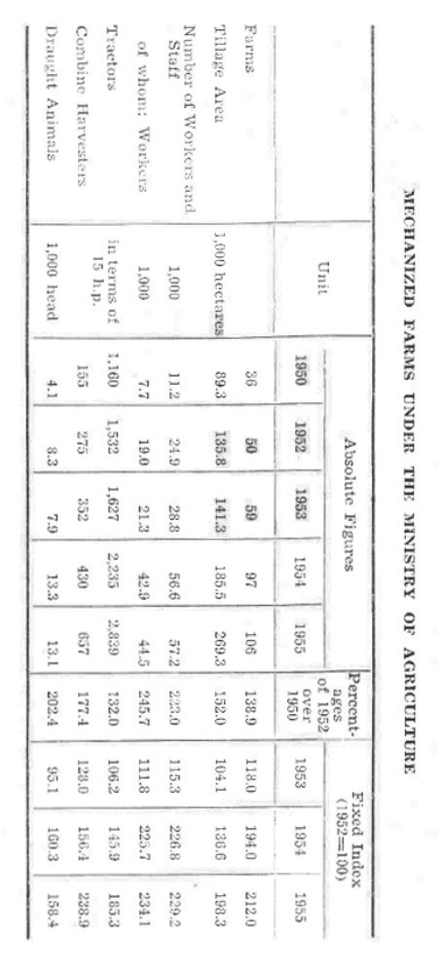
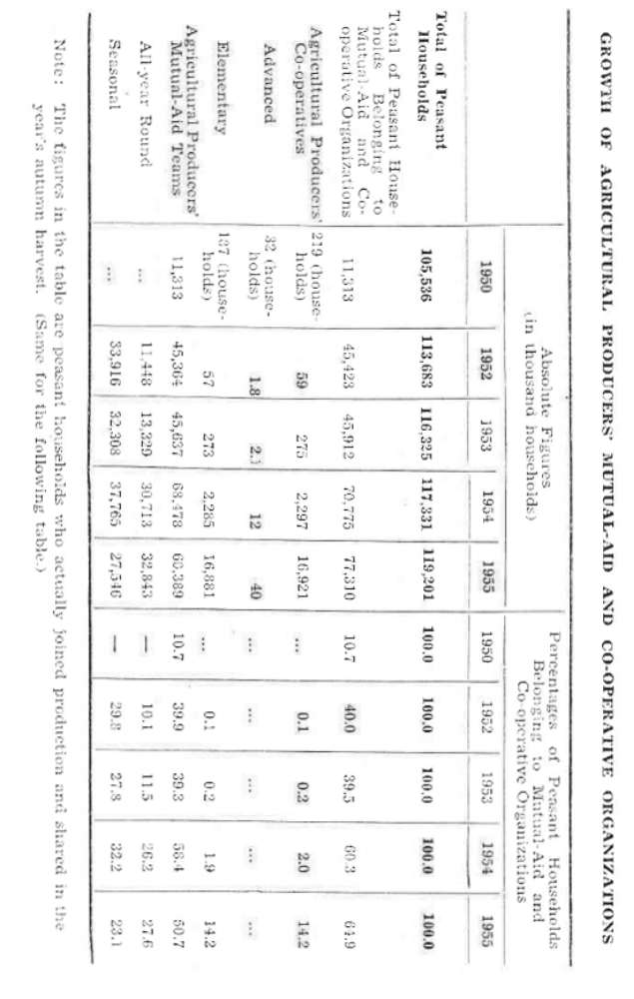
Type of Co-operative | 1950 | 1952 | 1953 | 1954 | 1955
Agricultural Producers' Co-operatives | 19 | 3,644 | 15,068 | 114,366 | 633,742
Advanced | 1 | 10 | 15 | 201 | 529
Elementary | 18 | 3,634 | 15,053 | 114,165 | 633,213
NUMBERS OF AGRICULTURAL PRODUCERS' CO-OPERATIVES
Note: By the end of May 1956, the number of agricultural producers' co-operatives reached 1,003,057, comprising 110,134,226 peasant households which accounted for 91.2 percent of the total peasant households. Of these, 302,756 were advanced co-operatives, comprising 74,720,054 peasant households which accounted for 61.9 percent of the total peasant households.
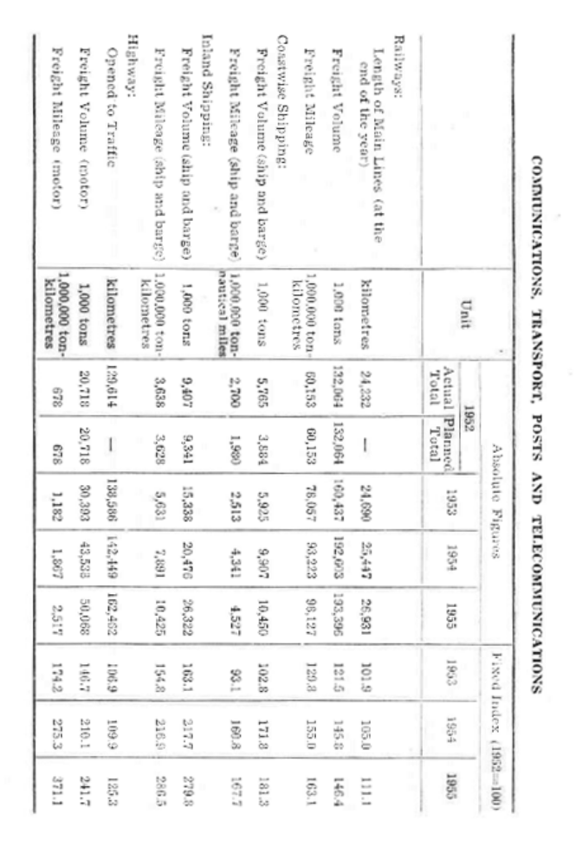

COMMUNICATIONS, TRANSPORT, POSTS AND TELECOMMUNICATIONS (continued)
 | Unit | Absolute Figures |  |  |  |  |  | Fixed Index (1952=100)
 | Unit | 1952 |  |  | 1953 | 1954 | 1955 | 1953 | 1954 | 1955
 | Unit | Actual Total | Planned Total
Civil Aviation:
Freight Volume (including mail) | tons | 2,047 | 2,047 | 3,607 |  | 4,734 | 4,711 | 176.2 | 231.3 | 230.1
Freight Mileage (including mail) | 1 k to km | 2,430 | 2,430 | 4,466 |  | 5,602 | 5,143 | 183.8 | 230.5 | 211.7
Posts and Telecommunications:
Volume of Business | 1 k yuan | 218,321 | — | 272,140 |  | 297,310 | 336,755 | 124.7 | 136.2 | 154.2
Note: Figures for private shipping in the Sungari River are not included in the 1952 figures for inland shipping as mentioned in the Five-Year Plan; figures for short-distance coastwise shipping under local jurisdiction are not included in the coastwise shipping.

PROPORTION OF FREIGHT MILEAGE HANDLED BY PUBLIC AND PRIVATE COMMUNICATION AND TRANSPORT ENTERPRISES
 | Absolute Figures (in million ton-km) |  |  |  | Percentages
 | 1952 | 1953 | 1954 | 1955 | 1952 | 1953 | 1954 | 1955
Ship and Barge | 8,642 | 10,286 | 15,936 | 18,823 | 100.0 | 100.0 | 100.0 | 100.0
State Enterprises Both Under Central and Local Administrations | 5,392 | 6,636 | 10,991 | 12,730 | 62.4 | 64.5 | 69.0 | 67.6
Joint State-Private Enterprises | 555 | 1,261 | 3,540 | 5,765 | 6.4 | 12.3 | 22.2 | 30.6
Private Enterprises | 2,695 | 2,389 | 1,405 | 328 | 31.2 | 23.2 | 8.8 | 1.8
Motor | 678 | 1,182 | 1,367 | 2,517 | 100.0 | 100.0 | 100.0 | 100.0
State Enterprises Under Local Administration | 339 | 647 | 1,307 | 1,958 | 50.0 | 54.8 | 70.0 | 77.8
Joint State-Private Enterprises | 4 | 11 | 37 | 101 | 0.5 | 0.9 | 2.0 | 4.0
Transport Co-operatives | — | — | — | 6 | — | — | — | 0.2
Private Enterprises | 335 | 524 | 523 | 452 | 49.5 | 44.3 | 28.0 | 18.0

PROPORTION OF COMMODITY RETAIL SALES HANDLED BY PUBLIC AND PRIVATE ENTERPRISES

1. Absolute Figures |  |  | (in million yuan)
 | 1950 | 1952 | 1953 | 1954 | 1955
Total | 16,794 | 27,665 | 35,041 | 38,962 | 40,002
State-owned Sector | 1,331 | 4,384 | 5,941 | 7,611 | 10,785
Co-operative Sector | 819 | 5,051 | 8,519 | 14,901 | 12,211
State Capitalist Sector and Pedlers Organized on a Cooperative Basis | 31 | 77 | 152 | 1,627 | 5,065
Private Sector (including peasants' trade) | 14,613 | 18,153 | 20,429 | 11,623 | 11,941
Note: Some of the figures for 1954 have been revised since their publication in the Report of National Economic Development of the State Plan in 1954. This applies to the following tables also.
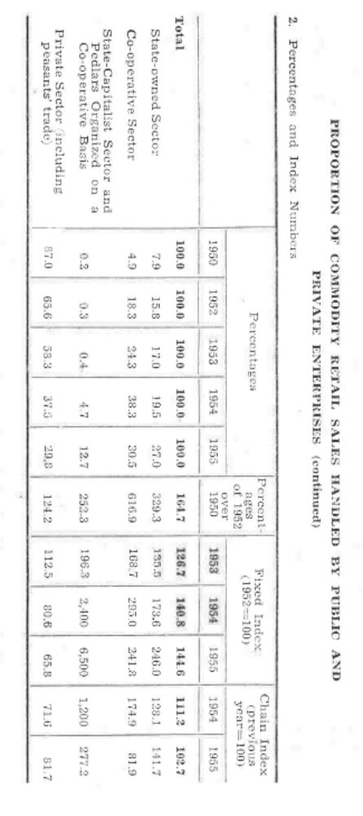
WHOLESALE AND RETAIL SALES IN COMMERCIAL ORGANIZATIONS
1. Absolute Figures
(in million yuan)
 | 1950 | 1952 | 1953 | 1954 | 1955
Total of Wholesale | 10,544 | 18,969 | 26,449 | 27,842 | 27,847
State | 2,448 | 11,469 | 17,543 | 23,347 | 22,884
Co-operative | 58 | 516 | 772 | 1,528 | 3,521
State-Capitalist and Pedlers Organized on a Co-operative Basis | 12 | 102 | 119 | 134 | 226
Private | 8,026 | 6,882 | 8,015 | 2,833 | 1,216
Total of Retail Sales | 12,083 | 21,027 | 27,981 | 31,586 | 32,321
State | 1,172 | 3,841 | 5,453 | 7,017 | 10,204
Co-operative | 819 | 4,999 | 8,368 | 14,444 | 11,548
State-Capitalist and Pedlers  Organized on a Co-operative Basis | 12 | 38 | 79 | 1,770 | 4,919
Private | 10,099 | 12,149 | 14,081 | 8,355 | 5,650

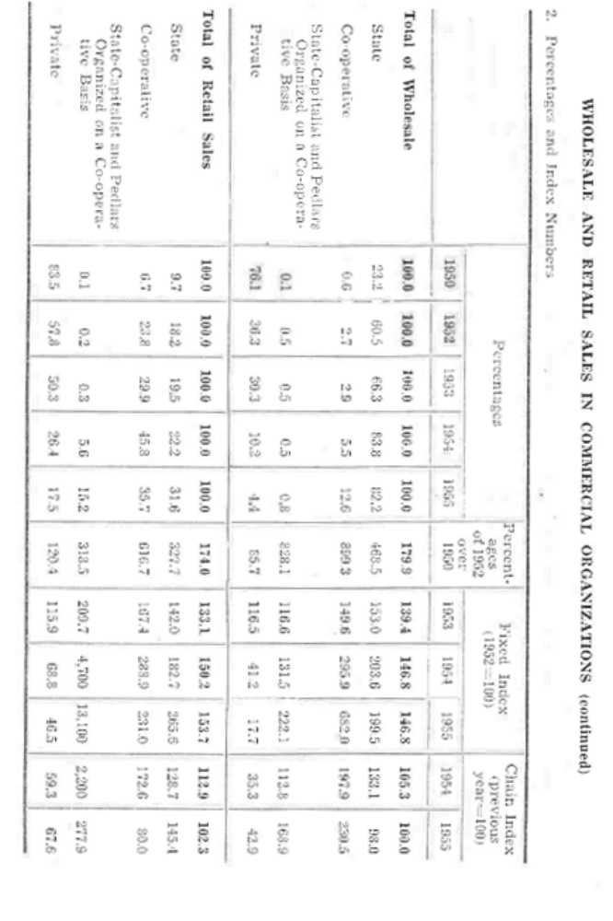
WHOLESALE PRICE INDEX NUMBERS
 | December of Previous Year=100
 | 1950 | 1951 | 1952 | 1953 | 1954 | 1955
January | 126.6 | 102.0 | 99.3 | 101.2 | 100.0 | 100.4
February | 203.3 | 102.2 | 98.7 | 101.3 | 100.0 | 100.5
March | 226.3 | 102.9 | 97.8 | 100.9 | 100.0 | 100.2
April | 169.9 | 104.4 | 96.8 | 100.6 | 100.0 | 100.1
May | 156.7 | 105.1 | 96.3 | 100.4 | 100.0 | 100.0
June | 155.8 | 106.6 | 95.6 | 100.6 | 100.0 | 100.0
July | 166.8 | 107.3 | 95.1 | 100.8 | 100.0 | 100.0
August | 173.6 | 111.9 | 94.8 | 100.8 | 100.1 | 99.9
September | 177.8 | 114.7 | 94.3 | 101.1 | 100.2 | 99.8
October | 185.3 | 115.1 | 93.5 | 101.1 | 100.4 | 99.8
November | 193.3 | 114.3 | 93.7 | 101.2 | 100.5 | 99.9
December | 193.2 | 113.2 | 93.7 | 101.2 | 100.7 | 99.9
Notes:
- The number of cities covered by this table is as follows: 15 in 1950; 25 in 1951; 47 in 1952; 44 in 1953; 42 in 1954; and 37 in 1955.
- Taking the average prices for 1950 as 100, the averages for each whole year are: 117.9 for 1951; 118.1 for 1952; 118.6 for 1953; 117.1 for 1954; and 117.8 for 1955. Taking the average prices for the whole previous year as 100, these averages are: 117.9 for 1951; 100.1 for 1952; 98.7 for 1953; 100.4 for 1954; and 100.6 for 1955.

NUMBERS OF STUDENTS
1. Absolute Figures (in thousand persons)
 | 1949/50 | 1952/53 | 1953/54 | 1954/55 | 1955/56
Total | 25,776 | 54,439 | 55,509 | 55,721 | 57,892
Higher Educational Institutions | 117 | 194 | 216 | 258 | 292
Post-graduate Students | 0.6 | 2.8 | 4.2 | 4.8 | 4.8
Regular and Special Courses | 116 | 191 | 212 | 253 | 288
Secondary Schools | 1,268 | 3,145 | 3,629 | 4,246 | 4,473
Secondary Vocational Schools | 229 | 636 | 668 | 608 | 537
Middle Schools | 1,039 | 2,490 | 2,933 | 3,587 | 3,900
Senior | 207 | 260 | 360 | 478 | 580
Junior | 832 | 2,230 | 2,573 | 3,109 | 3,320
Short-term Middle Schools for Workers and Peasants | ... | 19 | 28 | 51 | 36
Primary Schools | 24,391 | 51,100 | 51,664 | 51,218 | 53,126
Kindergartens | ... | 424 | 430 | 484 | 562

NUMBERS OF STUDENTS (continued)
2. Index Numbers
 | % of 1952/53 over 1949/50 | Fixed Index (1952/53=100) |  |  | Chain Index (previous year=100)
 | % of 1952/53 over 1949/50 | 1953/54 | 1954/55 | 1955/56 | 1954/55 | 1955/56
Total | 211.2 | 102.0 | 102.4 | 106.3 | 100.4 | 103.9
Higher Educational Institutions | 165.5 | 111.6 | 132.9 | 150.8 | 119.1 | 113.5
Post-graduate Students | 439.3 | 153.8 | 172.0 | 174.5 | 111.9 | 101.5
Regular and Special Courses | 164.1 | 111.0 | 132.3 | 150.5 | 119.2 | 113.7
Secondary Schools | 248.0 | 115.4 | 135.0 | 142.3 | 117.0 | 105.4
Secondary Vocational Schools | 277.7 | 105.2 | 95.7 | 84.5 | 91.0 | 88.3
Middle Schools | 239.7 | 117.8 | 144.0 | 156.6 | 122.3 | 108.7
Senior | 125.6 | 138.3 | 183.7 | 222.8 | 132.8 | 121.3
Junior | 268.0 | 115.4 | 135.2 | 142.6 | 117.2 | 105.5
Short-term Middle Schools for Workers and Peasants | ... | 149.3 | 271.6 | 194.0 | 181.9 | 71.4
Primary Schools | 209.5 | 101.1 | 100.2 | 104.0 | 99.1 | 103.7
Kindergartens | — | 101.4 | 114.2 | 132.4 | 112.6 | 115.9

NUMBERS OF STUDENTS IN HIGHER EDUCATIONAL INSTITUTIONS
1. Absolute Figures (in thousand persons)
 | 1949/1950 | 1952/1953 | 1953/1954 | 1954/1955 | 1955/1956
Total | 116.5 | 191.1 | 212.2 | 253.0 | 287.7
Engineering | 50.3 | 66.6 | 80.0 | 95.0 | 109.6
Agriculture | 9.8 | 13.3 | 12.8 | 12.8 | 17.3
Forestry | 0.6 | 2.2 | 2.6 | 3.1 | 4.0
Economics and Finance | 19.4 | 22.0 | 13.5 | 11.2 | 11.4
Political Science and Law | 7.3 | 3.8 | 3.9 | 4.0 | 4.8
Medical Science | 15.2 | 24.7 | 29.0 | 33.9 | 36.5
Physical Culture | 0.3 | 0.3 | 1.1 | 1.9 | 2.3
Natural Sciences | 7.0 | 9.6 | 12.4 | 17.1 | 20.0
Arts | 11.8 | 13.5 | 14.2 | 18.3 | 18.9
Teaching | 12.0 | 31.5 | 40.0 | 53.1 | 60.7
Fine Arts | 2.8 | 3.6 | 2.7 | 2.6 | 2.2

NUMBERS OF STUDENTS IN HIGHER EDUCATIONAL INSTITUTIONS (continued)
2. Index Numbers
 | Percent-ages of 1952/1953 over 1949/1950 | Fixed Index (1952/53 = 100) |  |  | Chain Index (previous year = 100)
 | Percent-ages of 1952/1953 over 1949/1950 | 1953/1954 | 1954/1955 | 1955/1956 | 1954/1955 | 1955/1956
Total | 164.1 | 111.6 | 132.3 | 150.5 | 119.2 | 113.7
Engineering | 219.6 | 120.1 | 142.7 | 104.6 | 118.8 | 115.4
Agriculture | 135.1 | 96.9 | 96.6 | 130.2 | 99.6 | 134.8
Forestry | 408.3 | 116.2 | 139.9 | 181.2 | 120.4 | 129.5
Economics and Finance | 113.5 | 61.3 | 50.8 | 51.9 | 62.8 | 102.2
Political Science and Law | 52.2 | 102.0 | 104.9 | 125.4 | 102.8 | 119.5
Medical Science | 162.5 | 117.3 | 137.0 | 147.3 | 116.9 | 107.5
Physical Culture | 115.2 | 337.2 | 584.6 | 702.5 | 173.3 | 120.2
Natural Sciences | 136.9 | 129.5 | 178.8 | 209.1 | 138.1 | 117.0
Arts | 114.2 | 105.4 | 135.8 | 140.3 | 128.8 | 103.3
Teaching | 262.1 | 126.6 | 168.3 | 192.3 | 132.9 | 114.2
Fine Arts | 130.2 | 75.3 | 71.1 | 62.4 | 94.4 | 87.8

NUMBERS OF STUDENTS IN SECONDARY VOCATIONAL SCHOOLS
1. Absolute Figures (in thousand persons)
 | 1949/1950 | 1952/1953 | 1953/1954 | 1954/1955 | 1955/1956
Total | 229.8 | 635.6 | 668.4 | 608.0 | 537.1
Engineering | 21.4 | 111.4 | 129.7 | 151.7 | 177.6
Agriculture and Forestry | 21.7 | 66.6 | 63.7 | 59.7 | 53.3
Public Health | 15.4 | 59.4 | 57.7 | 50.6 | 57.3
Economics and Finance | 14.8 | 52.3 | 42.3 | 26.8 | 26.0
Intermediate Normal Schools | 151.7 | 345.2 | 369.0 | 308.0 | 219.0
Fine Arts and Others | 3.8 | 0.7 | 1.0 | 2.2 | 3.9
Note: Figures before 1952/53 include a part of students in training classes (except Intermediate Normal Schools).

NUMBERS OF STUDENTS IN SECONDARY VOCATIONAL SCHOOLS (continued)
2. Index Numbers
 | % of 1952 /1953 over 1949/ 1950 | Fixed Index (1952/1953 = 100) |  |  | Chain Index (previous year = 100)
 | % of 1952 /1953 over 1949/ 1950 | 1953/1954 | 1954/1955 | 1955/1956 | 1954/1955 | 1955/1956
Total | 277.7 | 105.2 | 95.7 | 84.5 | 91.0 | 88.3
Engineering | 520.7 | 116.4 | 136.2 | 159.4 | 117.0 | 117.0
Agriculture and Forestry | 307.1 | 103.2 | 83.1 | 50.0 | 83.4 | 90.8
Public Health | 366.1 | 97.1 | 98.6 | 96.4 | 101.6 | 97.3
Economics and Finance | 353.4 | 80.8 | 55.0 | 49.8 | 63.1 | 90.5
Intermediate Normal Schools | 227.5 | 106.9 | 89.2 | 63.4 | 83.5 | 71.1
Fine Arts and Others | 19.0 | 142.8 | 310.7 | 538.8 | 217.6 | 173.4

CULTURAL INSTITUTIONS AND PUBLICATIONS
1. Absolute Figures
 | Unit | 1950 | 1952 | 1953 | 1954 | 1955
Film Projection Teams |  | 522 | 1,110 | 2,154 | 2,723 | 3,698
Cinemas |  | 641 | 749 | 779 | 815 | 859
Theatrical Troupes |  | 1,676 | 2,017 | 2,267 | 2,424 | 2,414
Theatres |  | 1,033 | 1,562 | 1,927 | 2,120 | 2,188
Cultural Centers |  | 1,093 | 2,443 | 2,441 | 2,392 | 2,413
Public Libraries |  | 63 | 83 | 93 | 93 | 96
Museums |  | 22 | 35 | 49 | 46 | 50
Newspapers, Annual Circulation | 1,000,000 | 798 | 1,609 | 1,672 | 1,711 | 1,954
Periodicals, Annual Circulation | 1,000,000 | 35 | 204 | 172 | 205 | 288
Books, Annual Publication | 1,000,000 | 275 | 786 | 755 | 940 | 1,080

CULTURAL INSTITUTIONS AND PUBLICATIONS (continued)
2. Index Numbers
 | % of 1952 over 1950 | Fixed Index (1952 = 100) |  |  | Chain Index (previous year = 100)
 | % of 1952 over 1950 | 1953 | 1954 | 1955 | 1954 | 1955
Film Projection Teams | 212.6 | 194.1 | 245.3 | 333.2 | 126.4 | 135.8
Cinemas | 116.4 | 104.4 | 109.2 | 115.1 | 104.6 | 105.4
Theatrical Troupes | 120.3 | 112.4 | 120.2 | 119.7 | 106.9 | 99.6
Theatres | 144.3 | 123.4 | 135.7 | 140.1 | 110.0 | 103.2
Cultural Centers | 144.6 | 99.7 | 97.7 | 98.6 | 96.0 | 100.9
Public Libraries | 131.7 | 112.0 | 112.0 | 115.7 | 100.0 | 103.2
Museums | 159.1 | 140.0 | 131.4 | 142.9 | 93.9 | 108.7
Newspapers, Annual Circulation | 201.7 | 103.9 | 106.3 | 121.4 | 102.3 | 114.2
Periodicals, Annual Circulation | 578.6 | 84.3 | 100.3 | 141.2 | 119.1 | 140.7
Books, Annual Publication | 286.1 | 95.0 | 119.6 | 137.4 | 124.6 | 114.9
Note: "1953" in the second row is now aligned above the column containing 194.1 (the second numeric column under "Percent-ages of 1952 over 1950").

PUBLIC HEALTH SERVICES
 | Unit | 1950 | 1952 | 1953 | 1954 | 1955
Beds in Hospitals | 1,000 | 99.8 | 160.3 | 181.1 | 204.8 | 221.0
of which: under Ministry of Public Health | 1,000 | 56.3 | 122.0 | 144.5 | 163.3 | 173.6
Beds in Sanatoria | 1,000 | 6.0 | 19.8 | 34.0 | 45.0 | 57.7
of which: under Ministry of Public Health | 1,000 | 3.9 | 8.1 | 11.2 | 14.9 | 18.1
Clinics and District Health Centers (under Ministry of Public Health) |  | 917 | 3,815 | 10,253 | 10,616 | 11,138
Clinics Co-operatively Run by Groups of Doctors and Other Joint Clinics |  | 803 | 15,047 | 22,470 | 25,285 | 31,165
Anti-Epidemic Stations (under Ministry of Public Health) |  | 30 | 112 | 260 | 264 | 263
Mother and Child Care Centers (under Ministry of Public Health) |  | 141 | 1,238 | 3,230 | 3,047 | 3,003
Doctors (Western school) | 1,000 | 41.4 | 51.7 | 56.4 | 63.0 | 70.5
Doctors (Chinese traditional medicine) | 1,000 | ... | ... | ... | ... | 486.7
1. Absolute Figures
Beds in Hospitals | 160.6 | 113.0 | 127.8 | 137.8 | 113.1 | 107.9
of which: under Ministry of Public Health | 216.8 | 118.4 | 133.8 | 142.3 | 113.0 | 106.4
Beds in Sanatoria | 330.0 | 171.7 | 227.1 | 291.6 | 132.3 | 128.4
of which: under Ministry of Public Health | 209.3 | 139.0 | 184.3 | 224.4 | 132.6 | 121.8
Clinics and District Health Centres (under Ministry of Public Health) | 961.3 | 116.3 | 120.4 | 125.4 | 103.5 | 104.9
Clinics Co-operatively Run by Groups of Doctors and Other Joint Clinics | 1,873.8 | 149.3 | 168.0 | 207.1 | 112.5 | 123.3
Anti-Epidemic Stations (under Ministry of Public Health) | 373.3 | 232.1 | 235.7 | 234.8 | 101.5 | 99.6
Mother and Child Care Centres (under Ministry of Public Health) | 875.0 | 260.9 | 246.1 | 242.6 | 94.3 | 98.6
Doctors (Western school) | 124.9 | 109.1 | 121.9 | 136.3 | 111.7 | 111.8
Doctors (Chinese traditional medicine) | — | — | — | — | —

LABOUR INSURANCE AND FREE MEDICAL TREATMENT
(in thousand persons)
 | Absolute Figures |  |  |  | Fixed Index (1552=100)
 | 1952 | 1953 | 1954 | 1955 | 1953 | 1954 | 1955
Numbers of Workers and Staff Enjoying Labor Insurance Benefits | 3,300 | 4,830 | 5,380 | 5,710 | 146.4 | 163.0 | 173.0
Numbers Receiving Free Medical Treatment | 4,000 | 5,496 | 5,666 | 5,937 | 137.4 | 141.7 | 148.4

Prepared by Maoism Library from https://www.bannedthought.net/China/MaoEra/Socialism/ReportOnNatlEconomicPlan-1955.pdf
One mou=one-sixth of an acre.
One Cubic meter = 35.5 cubic feet.
One square meter = 10.7 feet.
Figures are calculated on the basis of average postal and telecommunication rates for 1952
Whereas figures mentioned in the Report of National Economic Development of the State Plan in 1954 included only clinics co-operatively run by groups of doctors of Chinese traditional medicine and those jointly by the latter and the Western school of doctors, the figures in this table include also other joint clinics.

